St Neot Primary School

‘A happy learning environment for all’

Booklet for Parents
School Organisation
The Village Environment
Starting School

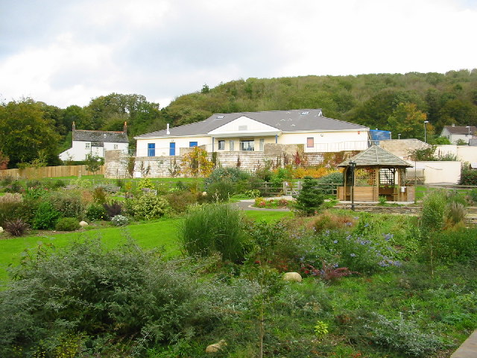

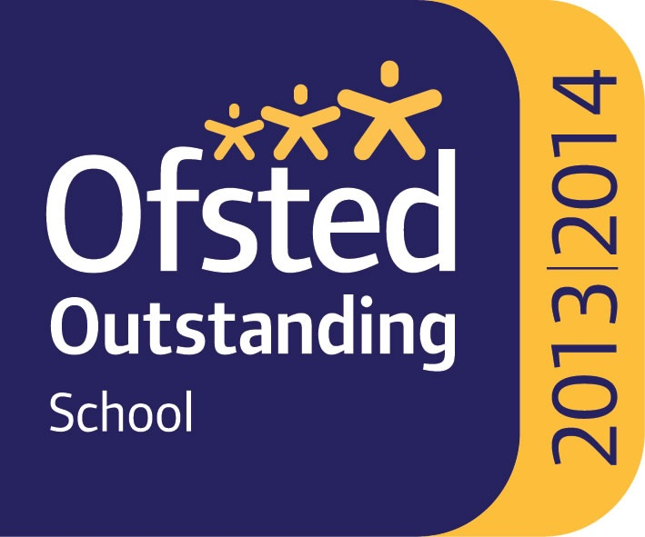

Welcome to New Parents

This booklet aims to inform you about the organisation and philosophy of St Neot School which meets the needs of children aged 4 to 11 years.

We have a long history-the school began in the 1870s and the new school was opened by HRH the Princess Royal in 2003. We have excellent accommodation comprising classrooms, hall and reception area grouped around a spacious library. Outside there are extensive grounds including garden areas, hard play, verandas, play equipment and sports facilities. Children attend from the village and a wide area beyond. Recently a Children’s Centre has been added to the school providing accommodation for Pre-School.

You and your child are very important to us. Each child is provided with work to suit their age and ability, and proceeds at an appropriate pace. Children are under the particular care of their class teacher who builds up a supportive relationship with them. We endeavour to ensure all children have a happy and purposeful education at all times. We aim to equip them with the necessary social and academic skills to enable them to achieve their full potential in today’s ever changing and technological society.

This booklet may not answer all your questions but we are always happy to discuss any matters individually with parents. A visit can always be arranged and you will be most welcome.

Please visit our website-www.st-neot.cornwall.sch.uk

CONTENTS

1 SCHOOL ORGANISATION

“How the School Works”
School and Home Partnership
The School Day The old school bell
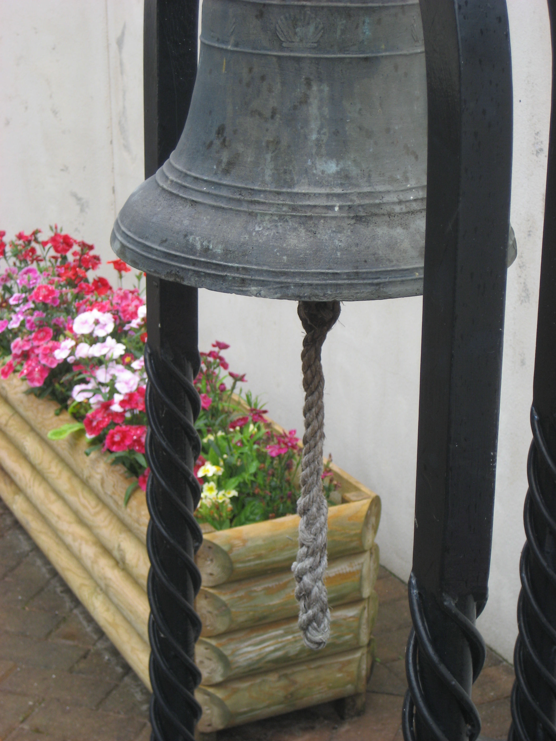
Recommended School Dress
Money and Valuables
School Lunches and Snacks
Free School Meals
School Transport and Parking
Charging for Various Activities
Parental Voluntary Help and Support
Whole School Events
Communications – Keeping in Touch
Health Matters
Year 6 Transfer to Secondary School
and St Neot Pre-School
Starting school as an older child

2 THE VILLAGE ENVIRONMENT AND SCHOOL ACCOMMODATION
“Where the Children learn”
St Neot
School Layout
Liskeard Cluster of Schools
Equal Opportunities

3 STARTING SCHOOL AT 4 YEARS OLD
“When we begin at school”
Ready! Before your child starts
Steady! The Foundation Stage
Go! Talking to parents

1. SCHOOL ORGANISATION

“How the School Works”

School and Home Partnership
We believe that home and school should form a partnership in order to encourage the overall wellbeing of all our pupils. We value our contact with parents and believe that this partnership and understanding is vital if our pupils are to develop and progress.
Parents are encouraged to contact school at the earliest opportunity should they have a concern. It is nearly always possible to speak informally or to arrange an appointment on the same day. If the school feels it necessary to contact home regarding a school-based problem, then this will be done as soon as possible.

Structured parents’ consultation evenings take place each term. These are held in October when parents have the opportunity to meet their child’s class teacher, in the spring term to talk about progress, and an opportunity in July after the annual reports have been sent home. These evenings enable parents to see the work that has been completed throughout the year, and to talk about ways of improving the children’s attainment. Open assemblies and open days are also arranged during the school year enabling parents to see the school during a working day.

Through our weekly newsletter we endeavour to keep parents and the community well informed. This provides up to date information on a variety of school and community matters and is delivered by satchel post as well as being on the website. Please ask if you do not receive your copy or inform the office if you wish to view the newsletter only online.

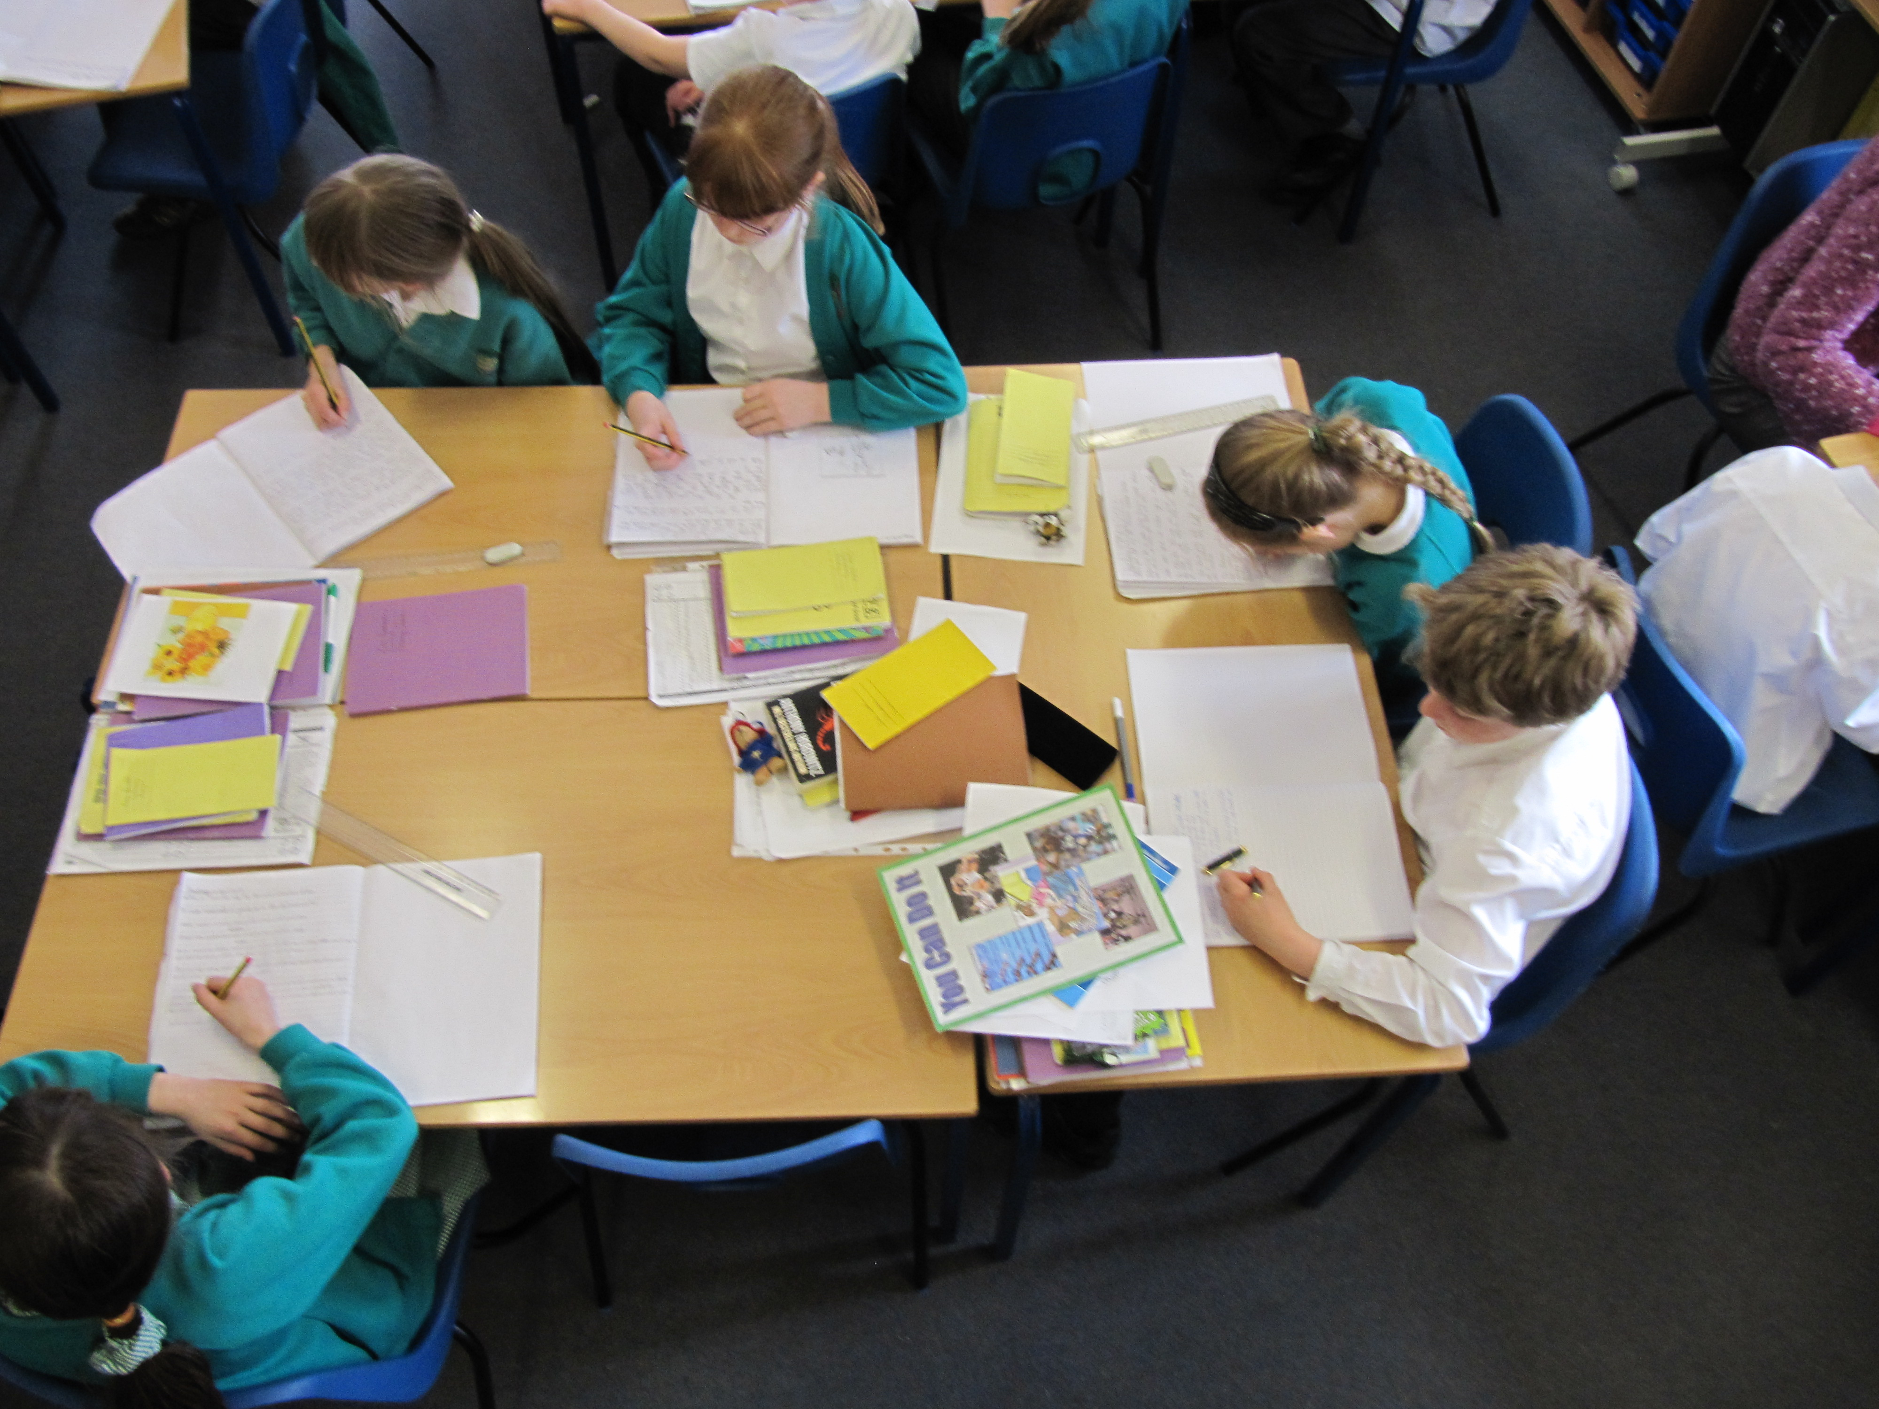

The School Day

8.00-8.50 Breakfast Club

8.45 am Children may arrive at school from 8.45 am onwards.

8.55 am Morning school starts for KS2

9.00 am Morning school starts for KS1

10.30 am Morning break of 20 minutes

12.00 Morning school ends for KS1

12.05 pm Morning school ends for KS2

12.05pm School lunch is provided in the Hall.

1.00 pm Afternoon school starts.

2.20 pm Afternoon break of 10 minutes for KS1.

3.10 pm End of school.
Children are supervised leaving school.

3.10-5.00 Riverside After School Child Care

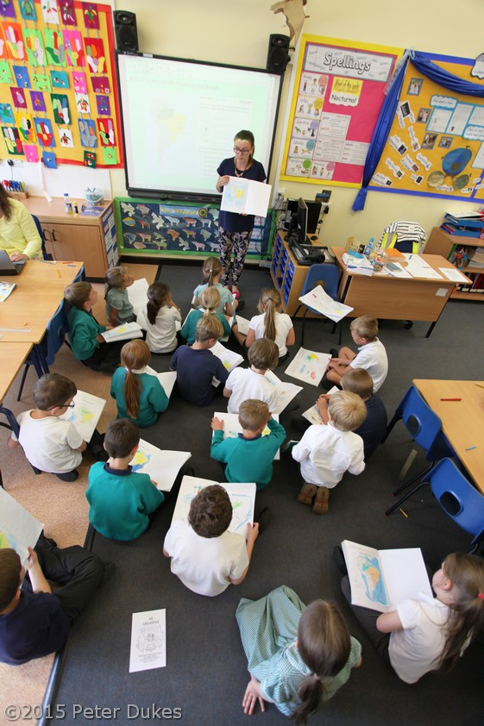

Recommended School Dress
The school’s colours are jade with white, navy, black or grey. Children are expected to dress tidily as follows (items indicated with an * are available to buy at school):
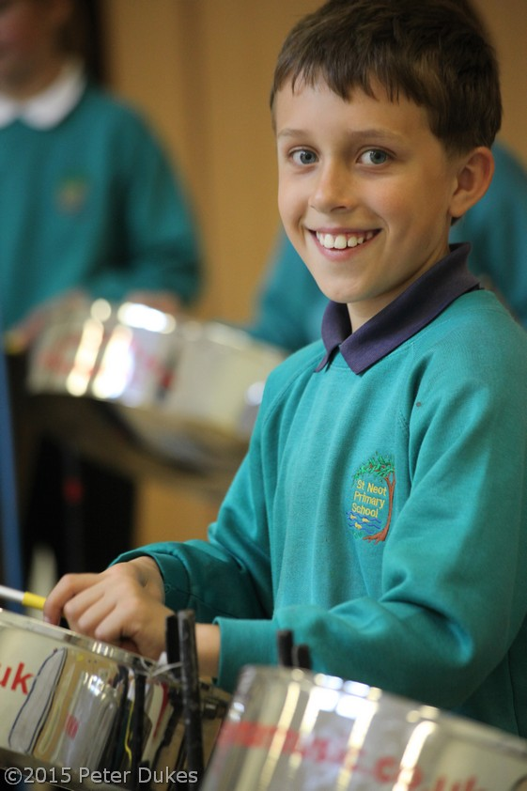
- Jade school sweatshirt*or cardigan*
- School polo shirt*, white or navy shirt or blouse
- Black or grey trousers or shorts, or culottes, not jeans
- Grey/Black skirt
- Navy Fleeces with the school logo*
- Dark shoes or trainers
- Dark or white tights
- Cap or Legionnaire hat*
- Please keep hair in a natural shade and conventional style

For safety reasons the following items are not permitted at school:-
- jewellery (except watches or ear studs)
- shoes with unsuitable heels or platforms/boots
- open toed sandals
- mobile phones

Essential P.E. Kit:
- Named, draw-string bag with: plimsolls, shorts, T-shirt in school colours*. Trainers for outdoor games and jogging bottoms are recommended.
- Children taking part in football/tag-rugby will need football boots or trainers. Second-hand boots are often available in school.
- Some short PE activities take place without changing into PE Kit but we ask that children always have PE Kit at school for longer lessons

Money and Valuables
These should be handed to the class teacher for safe keeping during the day. Pupils are asked to remove watches for PE and games. Valuables and toys should not be brought to school. Any dinner or trip money should be sent to the office in a named envelope.

School Lunches and Snacks
Lunch is cooked in the village hall and served in the school hall. Lunches are of good quality, being provided by Chartwells. Packed lunches may be brought if this is preferred and we encourage healthy food rather than chocolate, crisps or fizzy drinks. Money for school lunches should be sent in a labelled envelope on Monday mornings, cheques being payable to Chartwells.
Children are encouraged to bring a healthy snack to school to eat during morning break e.g. fruit or cereal bars. Key Stage One children receive a free piece of fruit each day from the Free Fruit and Veg scheme. Children in the Foundation Stage and those in receipt of Pupil Premium funding receive free milk daily; other children may purchase milk as required. Sweets are not allowed.
Free School Meals
Free school meals are available to all children in Foundation and Key Stage One, and to older children if the family is in receipt of Income Support, Job Seeker’s Allowance or Child Tax Credit. Currently in Cornwall there are 1700 children who are entitled to Free School Meals (FSM) but who do not take up their claim.
FSM entitlement is a trigger for Pupil Premium payments to the school. Parents can still register but need not take up their entitlement in practice should they so wish. A helpline number for free school meals - 01872 323298 – is there to answer questions from parents.

School Transport
Children who live two miles or further from school and who live within our designated area are entitled to free transport to and from school. More information is available from school or from the School Transport Unit at County Hall - 01872 322003.
Parking
Parents bringing children to school are asked to avoid congestion around the school by parking sensibly and walking their children to the school; some parents use the village car park and walk across the Doorstep Green via the footpath. Please do not park on the yellow markings outside the school or in the school car park which is for staff, visitors, disabled drivers and deliveries only.

Charging for Various Activities
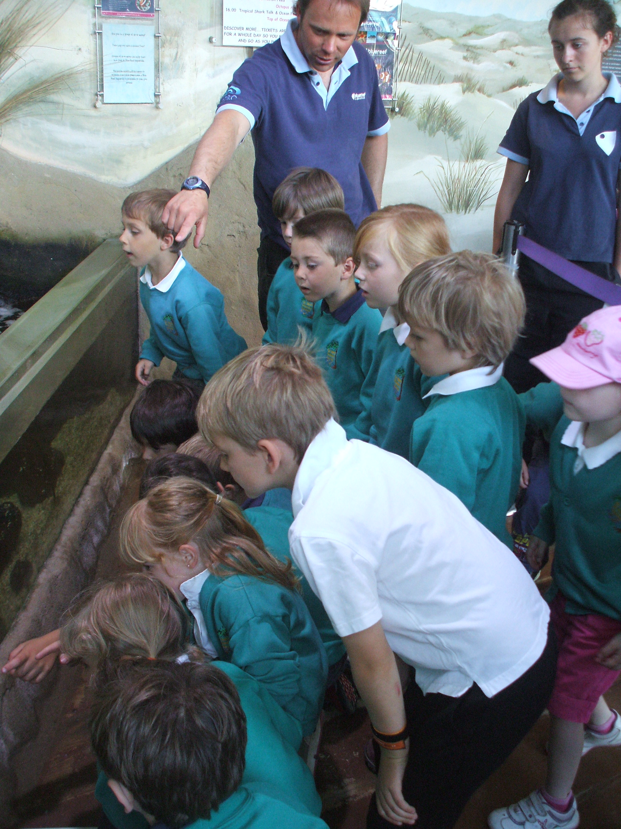
Visits and other activities are arranged, providing parents are willing to meet some costs on a voluntary basis. A copy of the Governors’ full charging policy may be seen in the school office and on the website. There has been a very positive response from parents when voluntary contributions have been requested and this has enabled many varied activities to take place. These have included swimming, visits to art galleries and museums, residential school journeys and theatre visits.

A visit to Newquay Aquarium

Parental Voluntary Help and Support
We have wonderful support from parents and community volunteers, assisting with a range of activities. This includes assistance with reading, educational visits, assemblies and sport. If you feel able to offer your time or skills, please speak to a member of staff and complete the voluntary assistant form. A DBS (formally a CRB) is required and you will need to register as a volunteer.

Whole School Events
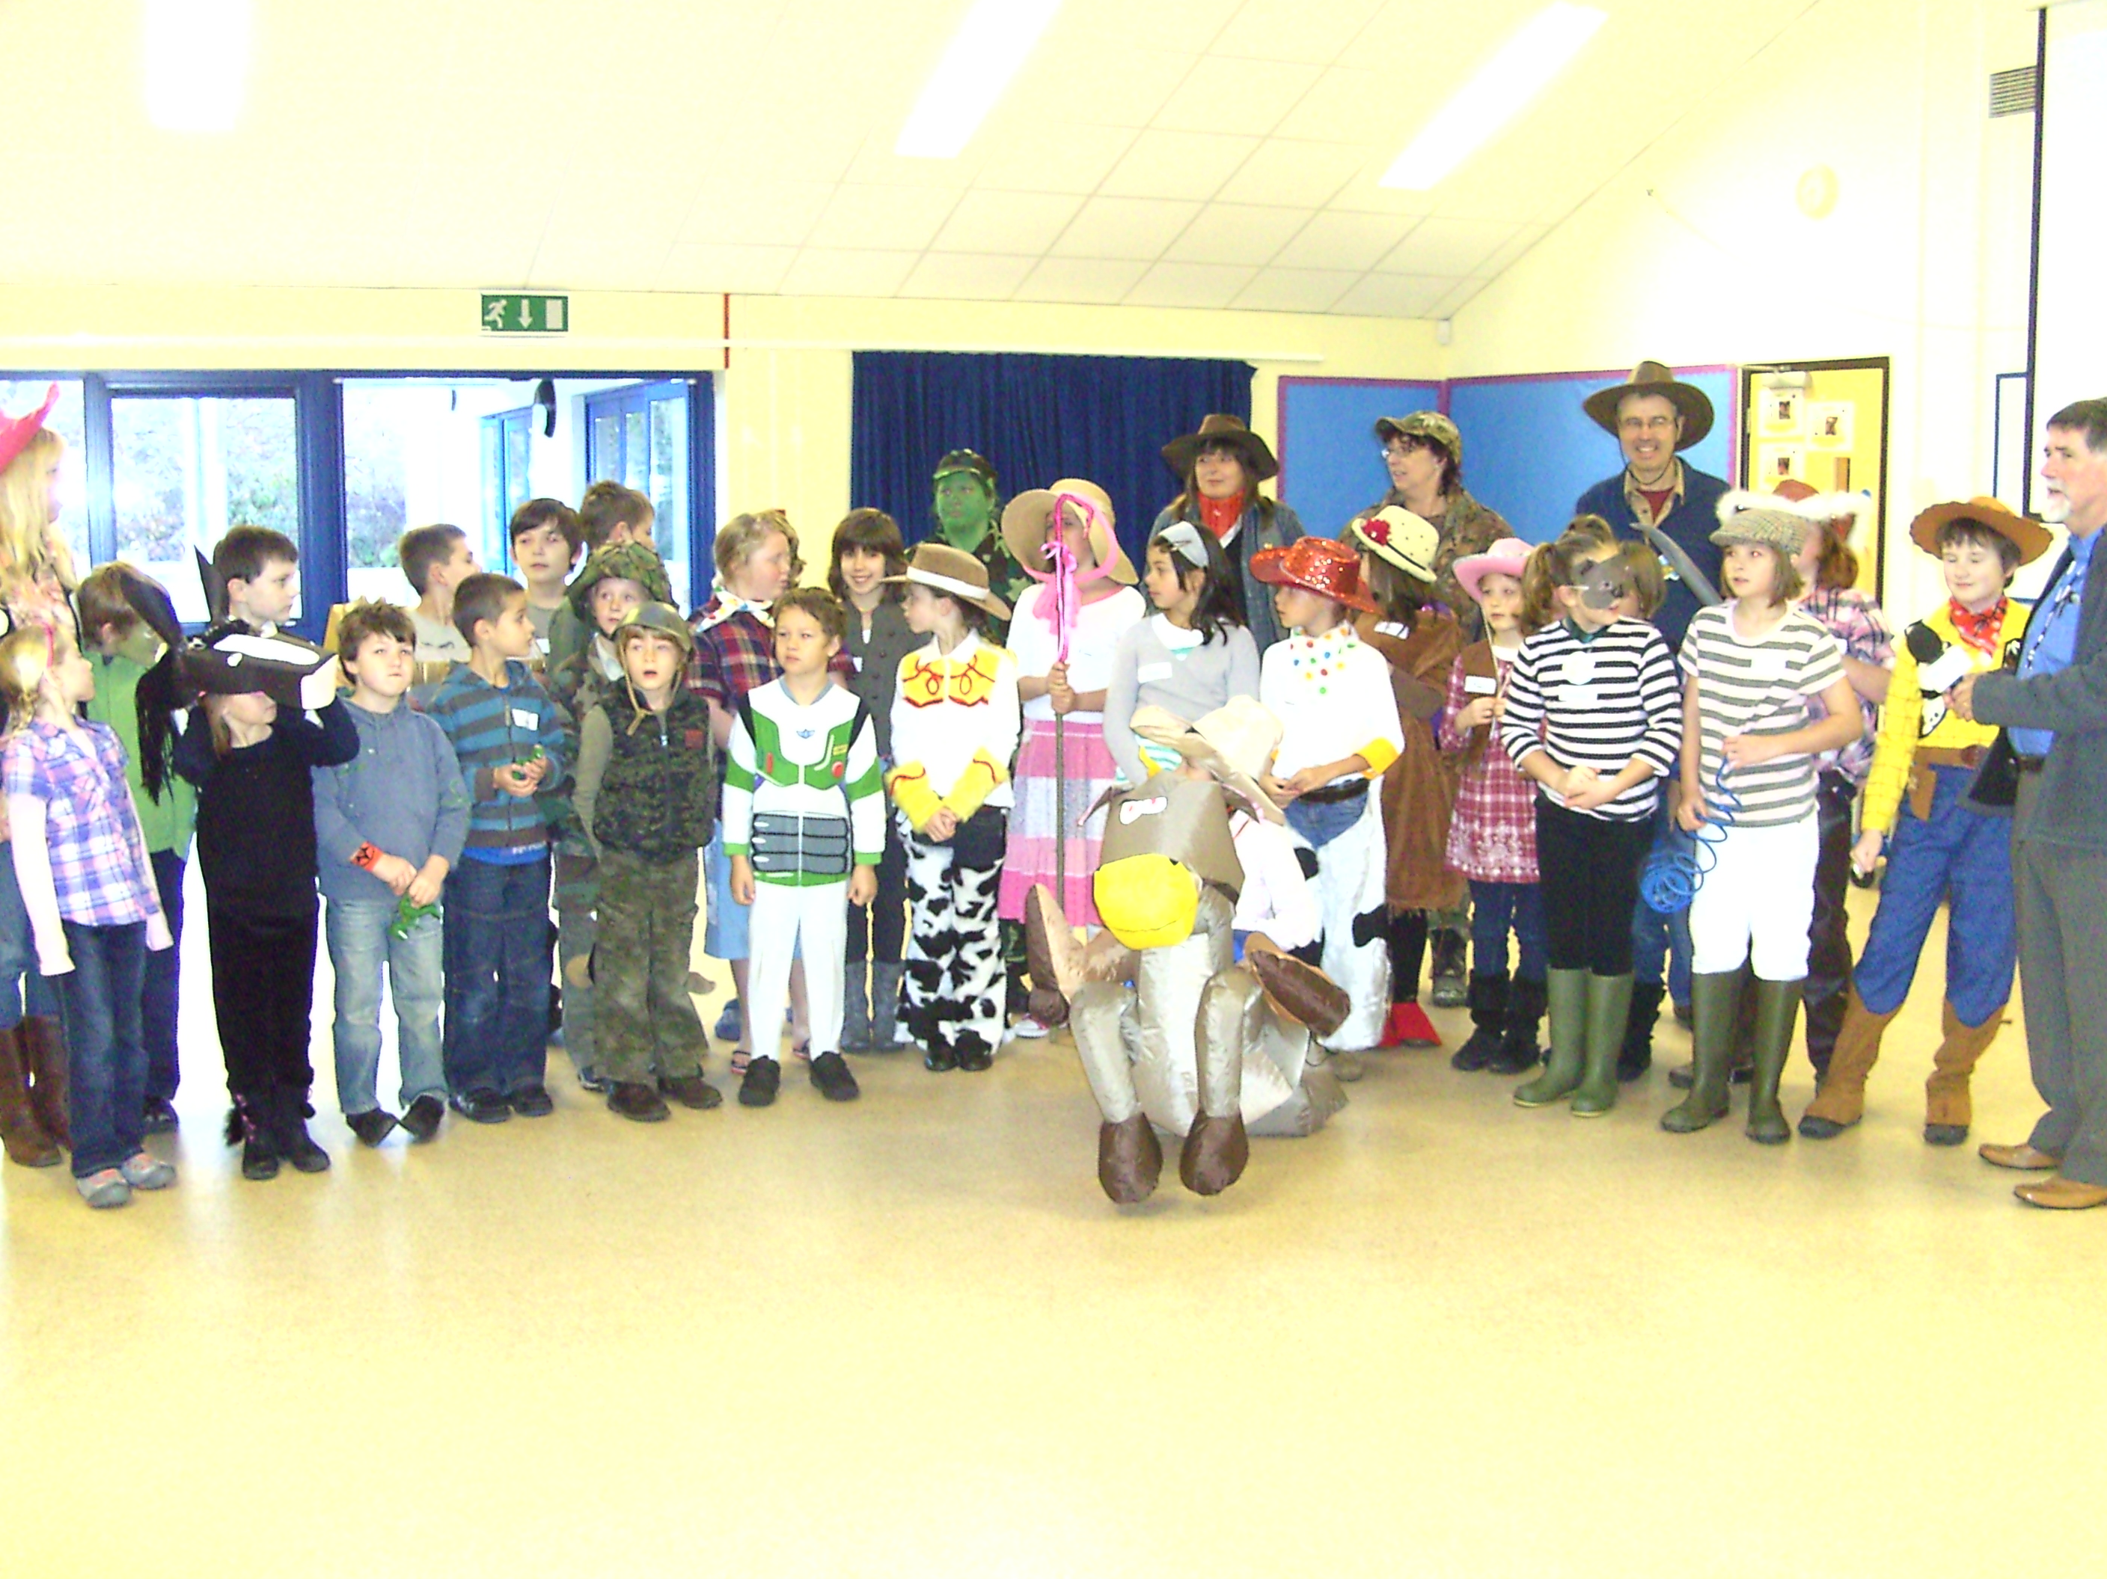
Whole School events are planned by the PTA. These events are very successful in raising money to purchase extra resources and their efforts are very much appreciated-recent purchases include a new stage and wireless microphones. Events have included a Shelterbox Sale, Book Fair, Autumn Disco, Film Evening and Christmas Fair.

Fundraising for Children in Need
Communications ….. Keeping in Touch
Many of the contacts between you and the school are of an informal nature – a quiet word with the Class Teacher or Headteacher is often appropriate.
Communications include:
- Newsletters – these contain news of coming events, requests for help and other information of interest to you. They are published weekly and are available on the website.

- Reports – these are issued annually, and will keep you informed of your child’s progress.

- Parents’ Evenings – these take place three times a year for a private discussion with your child’s teacher about achievement, behaviour and other.

- Appointments – if you have any worries about your child’s ability or progress please ask for an appointment to see the Class Teacher or Headteacher.

- Governors’ - Governors provide a point of contact – a list is provided at the end of the booklet.

- Letters – these should be sent to inform us of reasons for absence or to request that your child be excused from a PE lesson or swimming lesson.

- Website –www.st-neot.cornwall.sch.uk-providing a range of up-to-date information about the school, including events, policies and contacts. There is a link on our website to the parent centre.

- Email-the school office can be contacted at secretary@st-neot.cornwall.sch.uk

- Text messages-sent by the school office to alert parents of any changes i.e. cancellation of school club.

- Absence Forms- The Government recommends that family holidays are taken outside school terms. The Headteacher will only give permission for a pupil to be absent in exceptional circumstances, and after considering the pupil’s past attendance and the effects the absence will have on the pupil’s learning. The school cannot give permission simply because holidays cost less during term time. Please obtain an application form from the School Office before you make a booking. Forms should also be completed if your child will be absent for other reasons such as attending a funeral. All absences taken without approval will be marked as unauthorised and may attract a penalty fine from Cornwall Council.

Health Matters
- Please keep us informed of any changes to your address and telephone number, in case we need to contact you in an emergency.
- Should your child have an accident at school, first aid treatment will be given. You will be contacted if it is felt necessary that a hospital check-up or visit to the doctor is required, or if there is a head injury. You may receive an accident/incident/illness report slip at the end of the school day.
- Please keep children with infectious conditions at home, as advised by your GP, and inform us. A telephone call to School is usually sufficient.
- Should your child need to take prescribed medicine during the school day please complete the form available from the School Office.
- An asthma register is held in school – please complete the form if your child suffers from this condition.
- Please contact the School if you have any concern about sight, hearing or speech development which may be affecting your child’s well being.
- For safety reasons, no child is allowed to leave the School during the day unless collected by a parent or responsible adult. We would ask you to inform the school if your child is to be collected during the school day, for any reason, e.g. a medical appointment.
- A form is provided each year with end-of-day pupil collection details-please inform school if these arrangements change during the year.
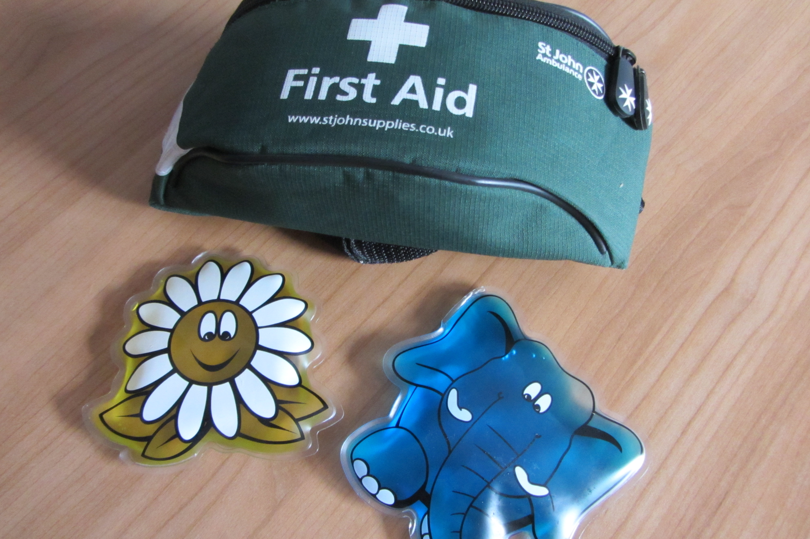
- The school nurse comes in to School regularly for various health checks including hearing and vision screening.
Admission to Primary School
All school admissions are handled by Cornwall Council, details can be found at
https://www.cornwall.gov.uk/education-and-learning/schools-and-colleges/school-admissions/

Visits to the school by prospective families are always welcomed and we are happy to answer any questions you may have. Please phone to speak to the Headteacher or to make an appointment to visit.

The school has a Pupil Admission Number (PAN) of 16. If a year group is oversubscribed please contact the school and we we may be able to help with your admission application.

Year 6 Transfer to Secondary School
We have excellent relationships with local secondary schools. Children transfer in the September after their 11th birthday, and a transition programme is available to pupils in the year before transfer. We feel that continuity between schools is vital, and every effort is made to ensure that transfer proceeds smoothly.

Recently children have transferred to Liskeard School, Looe School, Fowey School, Devonport High School for Girls and Boys, Plymouth High School for Girls, Callington College, Bodmin College, Kelly College and Launceston College.

Year 6 children visit their new school during the summer term and take part in a range of activities. Staff from the secondary schools visit St Neot on a regular basis to talk to the children.

Parents need to apply for places via Cornwall Council online at www.cornwall.gov.uk/admissions. Application booklets are also available from the school office from the September when your child is in Year 6.

Special Relationship with St Neot and Cardinham Pre-School
We have close links with both the local Pre-School

The Pre-School is based in the new Children’s Centre adjoining the school. Pre-School children visit on a regular basis, joining in with class activities or assemblies. Our staff also visit the Pre-School and there is good communication at all times. For further information about St Neot and Cardinham Pre-School please contact Mrs Di Bearne, pre-school leader, on 01579 326862.

Starting school as an older child
Families often move into the area or transfer their child from another school when their children are older than 4 years. New parents and children are invited to look around the school, meet the staff and talk to the headteacher. Please contact the school to arrange this. Special arrangements are made to make sure that new pupils settle in quickly.

Applications for admission need to be made to Cornwall Council via County Hall, Truro at:
www.cornwall.gov.uk/admissions phone 03001 234101.

The published admission number is 16 pupils per year group.

2 THE VILLAGE ENVIRONMENT AND

SCHOOL ACCOMMODATION

“Where the Children Learn”
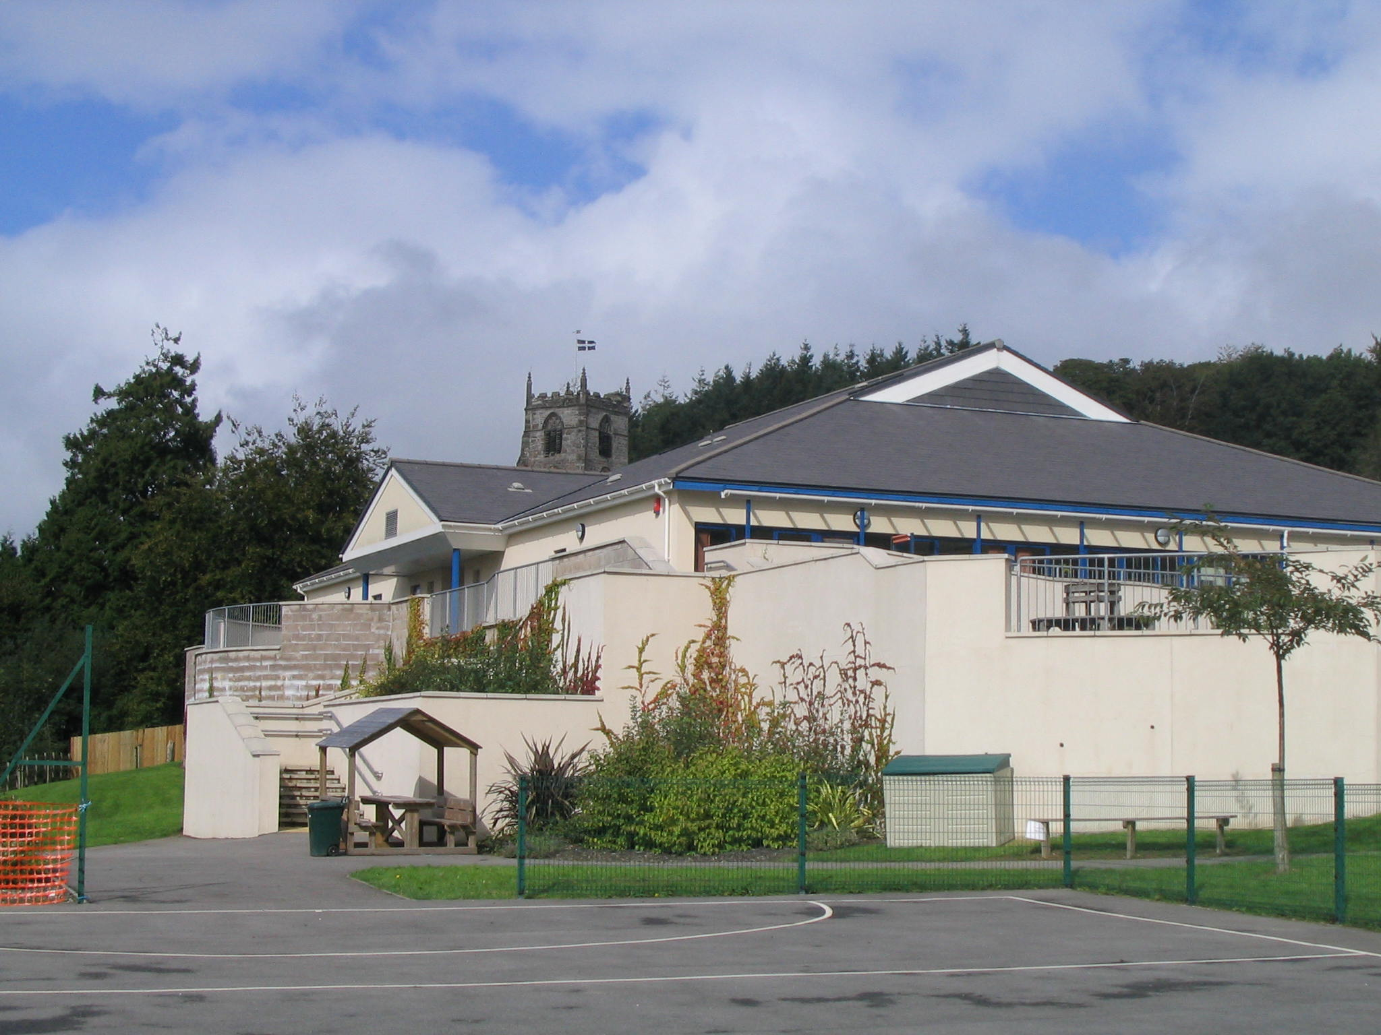

St Neot School and Church

St. Neot Village

The village of St. Neot gently nestles in the Glynn Valley, beautifully situated within the wide loop of the Loveny River on the southern side of Bodmin Moor. The village church stands above the rooftops and is famous for its stained glass windows which date back to the fifteenth century.
In the past a number of mines would have been seen working around the village although little evidence of this now remains. Just outside the village we can still see a lone stack and the ancient earthwork called “The Crowpound”; according to tradition this is where St. Neot took the crows on Sundays so that the farmers could go to church not having to worry about their crops being eaten.

St. Neot is a lively community with a wide range of activities taking place in the village. The Village Hall, Doorstep Green and Playing Field are in constant use throughout the week providing venues for children’s activities. In recognition of the exceptional environment in the village, St Neot won the National Village of the Year competition in 2004 and in 2006 was voted Village of the Decade. The school is adjacent to the new Village Green, incorporating an amphitheatre and gardens.

School Layout

The school was built in 2003 and provides a bright and spacious learning environment for the pupils and staff to enjoy. Inside facilities include three classrooms, library, hall, resources room, under fives play area and staff accommodation. Outside there are hard-surfaced play and games areas on different levels, in addition to grassed areas and banks, giving an attractive sculptured appearance to the school grounds. A Children’s Centre is attached to the school. At present there are three classes who work with their own class teacher and classroom assistants.

Liskeard Cluster of Schools
Various joint ventures take place with local primary schools who form a cluster of schools around Liskeard. The schools share resources, training and expertise.
Equal Opportunities
We value the uniqueness and respect the worth of each member of our school community regardless of ability or background, encouraging each one to achieve their full potential.
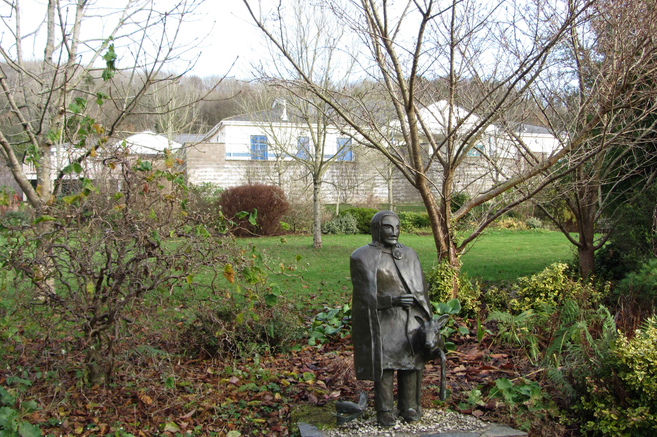
We promote within our school community a caring, yet challenging, environment for teaching and learning where equal opportunities and individuality are respected.

The statue of St Neot on the Doorstep Green

3. STARTING SCHOOL AT 4 YEARS OLD

“When we begin at school”

Children are admitted to school full time the September following their fourth birthday through the Cornwall Council Admissions system.

- Parents applying for a place need to complete the Admission Form on line at https://www.cornwall.gov.uk/education-and-learning/schools-and-colleges/school-admissions/
- Admission information is distributed in September; please ask at the School or Pre-School for a copy. We suggest that parents check that their application has been received.
- We ask that parents fill in a separate contact form and hand this to the school office so that we have a record of who has applied.
- All admissions are administered from County Hall. Parents who do not receive their first choice school can appeal and will often be successful. We can support parents who wish to appeal. Governors are firmly of the opinion that local children should always be offered a place at their local village school.
- Parents considering enrolment are invited to telephone or call to make arrangements for an initial visit. Early enrolment is appreciated as this helps us with planning.
- All new parents and children are invited to attend introductory sessions during the summer term to enable a gradual start to school.
- Admissions may be deferred until compulsory school age (the term after the child’s 5th birthday) if parents wish.

READY!
“Before your child starts”

You will receive an invitation for your child to come to school for introductory sessions in June/July. Your child will be able to meet all their new classmates. Parents are welcome to stay with their child for part or all of these sessions as needed. The staff and children of St. Neot Pre-School visit us at other times during the year too. Your child will also receive an activity/introduction pack as well as their new book bag.
New parents are invited to a meeting with teachers and other staff in order to share more information about starting school and allow parents a chance to let us know if they have any queries about starting school.
Parents are central to the education of their children and we aim to provide you with as much support and advice as possible concerning their child’s education.
Before your child starts school it is always helpful to talk to your child about starting school and what it might be like. Please encourage your children to learn to dress and undress by themselves in preparation for P.E and going to the toilet etc. It is also helpful if parents teach their children how to use cutlery.
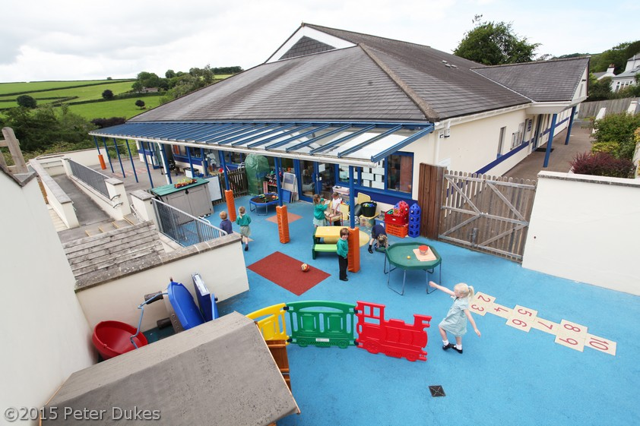

STEADY! “The Foundation Stage”

Foundation Stage learning at school is based on planned play, with more structured activities being introduced during the year. The activities vary according to subject with children also having opportunities for self-initiated play. Learning takes place individually, in groups and as a whole class.
We follow the Early Years Foundation Stage which is divided into seven areas of learning:
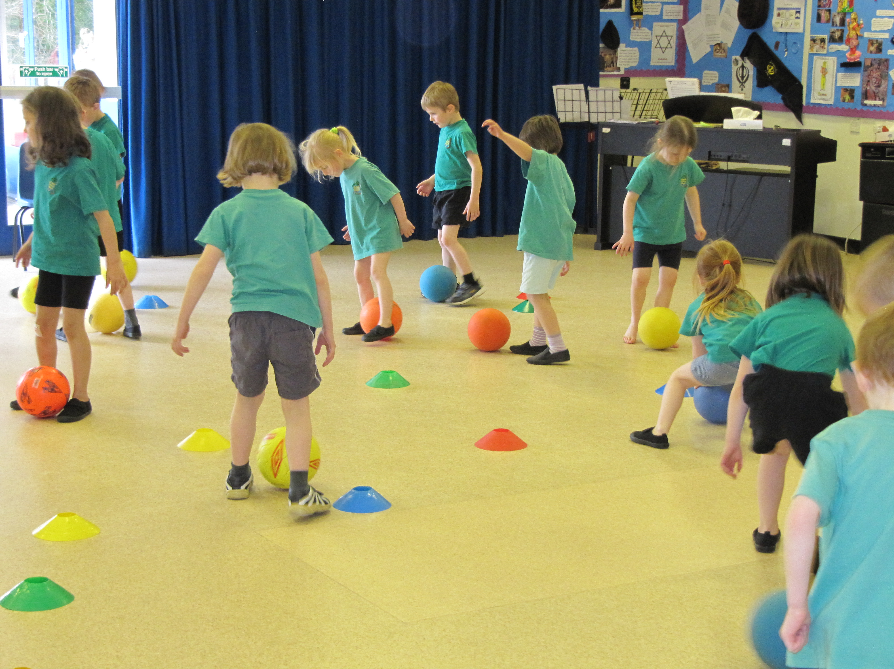
- Communication and Language
- Physical Development
- Personal, Social and Emotional Development
- Literacy
- Mathematics
- Understanding the World,
- Expressive Arts and Design.
The children learn at their own pace with support until they achieve the Early Learning Goals, usually by the end of their Foundation Year. Learning opportunities take place outside as well as in the classroom. And we organise regular visits out of school with our children in connection with our topics.
Each child’s progress is documented in their personal Learning Journey - this is a detailed record of your child’s path through their first year at school and will be shared with you at consultation evenings.
Your child’s time in the Foundation Stage will go by very quickly!
We invite parents to meet with us after your child has attended school for about six weeks in order to let you know how your child has settled into school and to discuss their progress to date.
There will also be further opportunities each term for Parent Consultations. Staff are always keen to talk to parents about the children’s progress and welfare and are always available before and after school for quick informal chats, but please ask for an appointment if you want to discuss anything in detail. If there is anything urgent we will, of course, see you straight away.
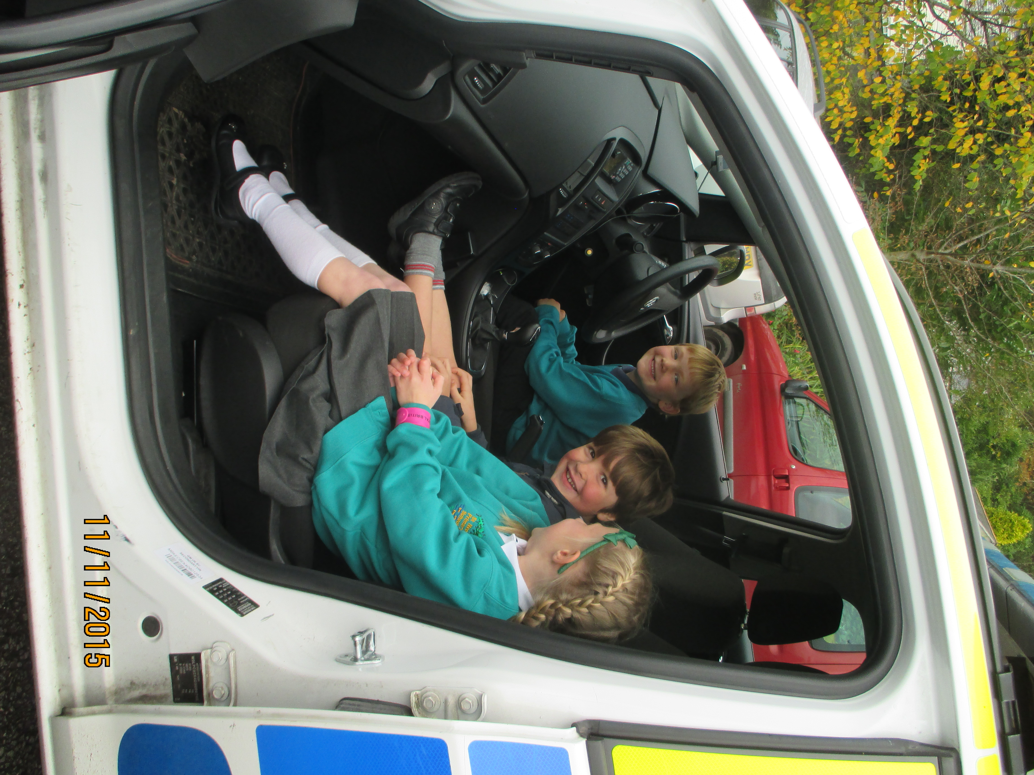

GO!
“Watch how the children make progress”

Reading

We encourage the children to become independent as soon as they start school and we give them the tools to do this at a time which is appropriate to each individual child. Some children will take home a school reading book very early while others may not need one until later. Children usually begin with books with few or no words to begin with. The earliest stages of reading consist of being able to talk about pictures and tell a story from the pictures alone.
When practising reading at home please use different ways to help your child, allow children to make mistakes in their reading, guess the word, say the whole word, say the sounds they see and blend them to attempt unknown words.
Please encourage the children to learn about letter sounds before letter names. We teach the children to say the sound of a letter-
- ‘c’ as in cat (not see)
- ‘a’ as in ant (not ay)
- ‘s’ as in snake (not ess)

Writing

Writing begins with mark making using different tools such as coloured pencils, felt tips and paint. Children begin to learn to form letters and numbers by forming shapes in sand, tracing and eventually copying. This quickly moves on to self initiated writing where the children give meaning to their marks, forming coherent words and eventually sentences.
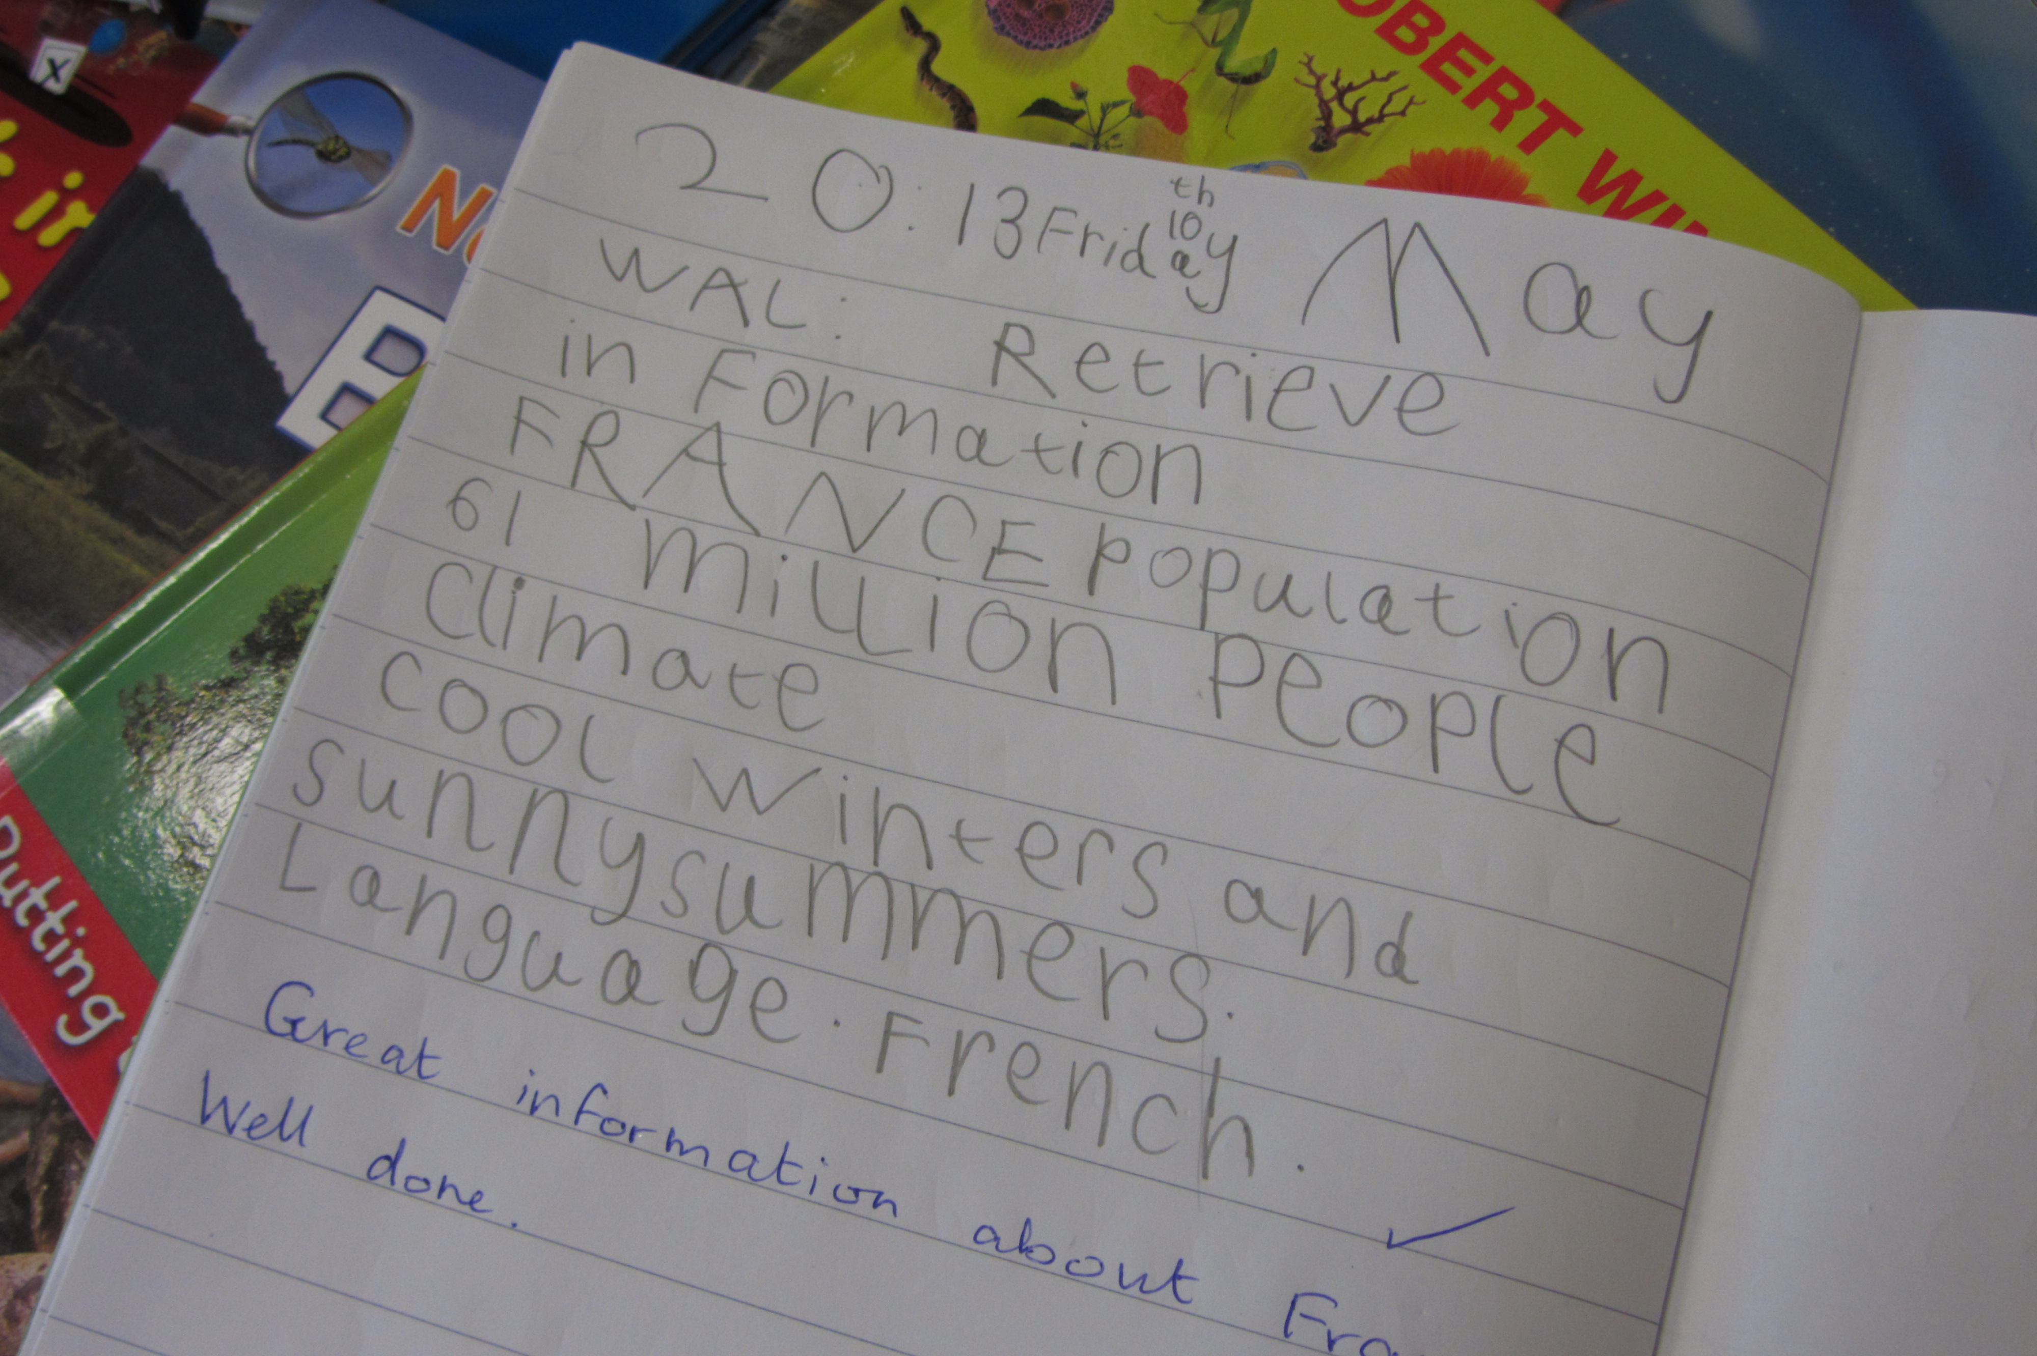
We will provide you with a sheet which shows you how to form lower case letters so that you can begin to help your child learn to write their own name before they start school. Parents can also help their children by giving them fine motor control activities before starting school. Try using playdough, painting, drawing, colouring, jigsaws, sewing, water play or lego building. There are lots of useful activities on the internet-try looking at
www.underfives.co.uk under ‘Early Learning Resources’.

Speaking and Listening

The ability to speak confidently and listen carefully is a key objective for children in their first year and there are all kinds of activities to encourage this, including listening to stories, drama and group discussions. Parents can help too by reading stories, chatting to their children around the home and encouraging them to follow simple instructions.
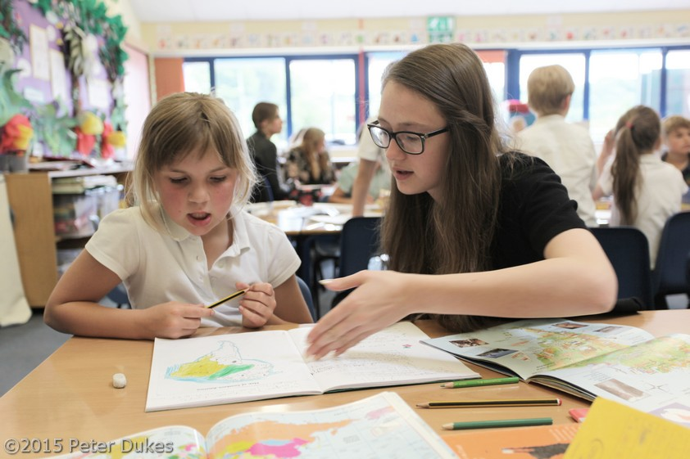

Volunteer helpers are always welcome

Mathematics
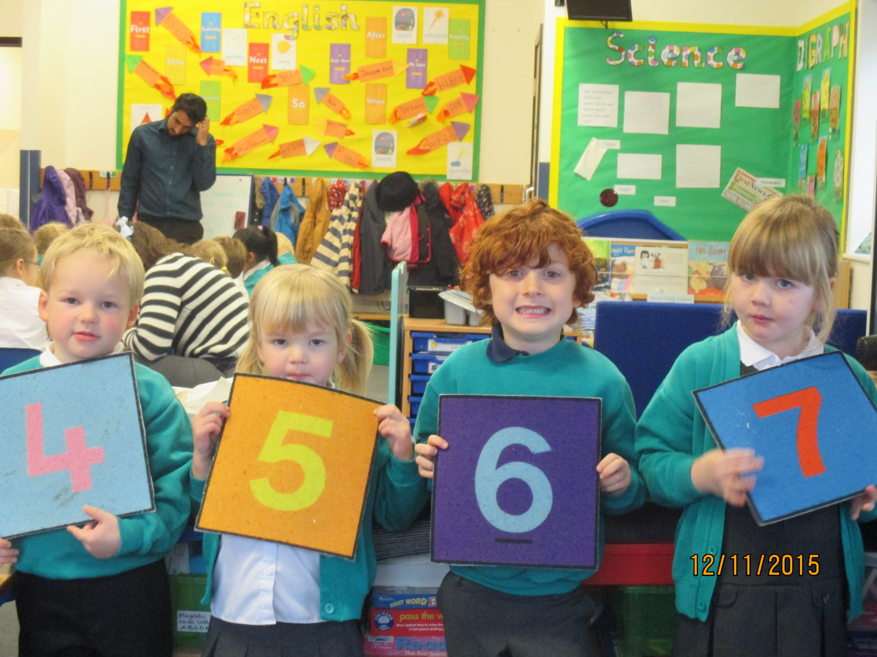
Mathematics is not only about numbers but also shape, size and the understanding of ideas such as full and empty. The concept of number is introduced through sorting and counting activities. The myriad mathematical ideas such as shape, space and measure are introduced through practical activities which culminate in understanding and recording. Parents can help with maths by playing board games, counting steps, stairs, breakfast bowls, coins etc. Talk to your child about shapes they can see, which window is biggest, who has the smallest feet and you will soon have a child who is well prepared for maths at school.

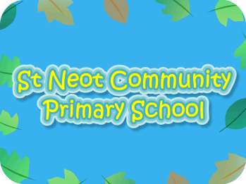
www.st-neot.cornwall.sch.uk

