Treverbyn Class: Friday 8th January
Morning lessons are expected to begin at 9.00am and finish at 12.00pm. Please ensure children have a snack and light exercise between lessons 2 and 3. Afternoon lessons are expected to begin at 1.00pm and finish at 3.00pm. For the benefit of children’s health and well-being, we strongly encourage all children to exercise regularly.
If your child is unwell and unable to complete the learning tasks, you must notify the school and give details by emailing secretary@st-neot.cornwall.sch.uk by 9.30am.
Lesson 1  30 minutes | Lesson 2  1 hour | Lesson 3  1 hour | Lunch and break | Lesson 4  1 hour | Lesson 5  30 minutes
Spelling, Punctuation and Grammar | English | Maths |  | Art | Reading

Lesson 1: Spelling, Punctuation and Grammar
Learning Objective: To use spelling words correctly
Resources: Lined Paper / Pencil
Explain to children that they are going to be practising their weekly spelling words (see lists below). Ask children to write out each spelling word neatly and correctly at least three times. Ensure that children are spelling the words correctly and can identify the tricky parts of the word (if necessary). Make sure that children understand the meaning of the less familiar words and can use them verbally in a sentence. Once children have practised their spellings, they should choose 5 of the spelling words. Each of these 5 spelling words should be used in an interesting and descriptive sentence. Remind children of the expectation for punctuation, careful spelling and neat handwriting.

Year 2 | Year 3 | Year 4
copied  replied  spied  fried  relied  applied  identified  multiplied  magnified  supplied | obey  prey  convey  survey  osprey  grey  disobey  they  surveyor  conveyor | courageous  outrageous  nervous  famous  adventurous  advantageous  ridiculous  carnivorous  rapturous  torturous

Spelling practice does not need to be evidenced. If possible, please check that spellings are correct and that sentences make sense. If you are balancing work / home learning and you would like to have the worked checked by an adult at school, please feel free to send it over

Lesson 2: English
Learning Objective: To answer a range of questions relating to fiction texts.
Reading Comprehension Packs (Text, Questions and Answers)
- Explain to children that they are going to be completing a reading comprehension activity which means they have to answer questions about a text that they have read in order to show that they fully understand it. The children will be reading two different “Traditional Tales”; one from South Africa and one from The Philippines. Can you find where these countries are on a map?
- There are questions that children will need to answer throughout the text that follow six main themes: Vocabulary (understanding the meaning of words), Inference (looking for clues in the text to draw conclusions), Prediction (using imagination and prior knowledge to suggest scenarios which could happen next), Explanation (explaining events and occurrences in the text), Retrieval (identifying information in the text to answer simple questions), Sequence (ordering events from the text). These questions are labelled with a letter so that children can begin to recognise what type of question it is and what is required for them to answer it.
- Give the children the first text: Jackal and the Lion. Children to read through the text by themselves (or aloud to an adult), identifying any unfamiliar or tricky words.
- Show children the first group of questions, and encourage them to re-read the text to find the answers. Underlining answers/relevant information in the text is a good strategy to support reading comprehension and ensure that children fully understand the questions and have identified the appropriate text to answer them correctly. Please note, there is a mistake in the first question! There are only two words in the text that mean “clever”.
- Children to complete the second group of questions, re-reading the associated paragraphs to find the correct answers.
- Answers to the comprehension questions are provided for guidance if necessary.
- Once children have completed the first text, there is an extension text: The Boastful Turtle. This reading comprehension follows a similar structure with the same question types.

Lesson 3: Maths
Learning Objective: To solve problems involving addition
Resources: Column Addition Worksheets / Pencil
Starter: Counting on in tens.
Year 2 and 3 – Give children a two-digit number. Can children continue counting on from that number in steps of ten? For example: 57…. 67, 77, 87, 97, 107, 117, 127, 137. Repeat with different numbers. Extend children by giving them a three-digit number. For example: 234… 244, 254, 264, 274, 284, 294, 304, 314.
Year 4 – Give the children a three-digit number. Can children continue counting on from that number in steps of ten? Extend children by giving them a four-digit number (if necessary).
Main Activity: Problem Solving
- Explain to children that they will be using their understanding of addition to solve a maths problem. Show children the number grid and explain the problem to them. Remind children of the addition strategies that they could use to help add four numbers together (mental strategies, partitioning or column addition).

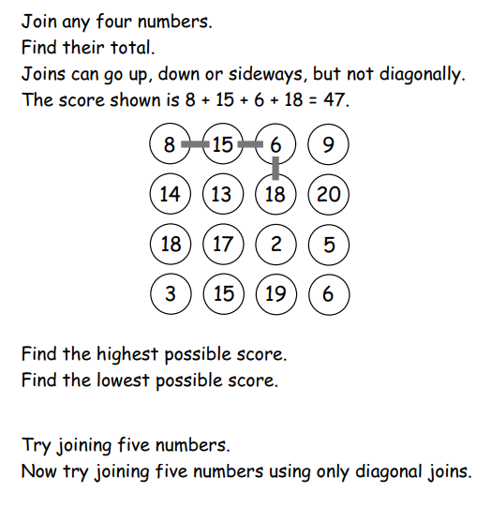
- Read the instructions and ensure that children understand the problem. Remind children that they must show their number sentences and working out for each addition that they complete. Please encourage children to persevere and try different combinations of numbers in order to solve the problem.
What is the smallest number you can make by joining four numbers and adding them together?
What is the largest number you can make by joining four numbers and adding them together?
- As an extension, repeat using five numbers, ensuring that children record their number sentences and working out.
- If children are finding it difficult to add four numbers, reduce the number to three (extending to four if necessary).

Please ensure all tasks from morning lessons are submitted to treverbyn@st-neot.cornwall.sch.uk by 1.00pm at the latest.
Lesson 4: Art
Learning Objective: To create a sound map to represent sounds in our local environment
Resources: Paper / Pencil
- Show children the Power Point introducing the Art lesson. Make sure that you “start slide show” to make sure the information on each of the slides is revealed in the correct order.
- What is an environmental artist? Children to discuss what they think this might mean, focusing on the two words as separates before trying to form a relationship between the two. After discussing what an environmental artist is, encourage children to think of some of the environmental problems that the planet may be facing at the moment.
- Work through the Power Point with children, before explaining that they are going to create their own sound map to represent the sounds that they can hear in nature. Take a piece of paper outside, or on a walk in the local area. Encourage children to draw a picture of themselves in the middle of the page, before listening carefully to the sounds that they can hear around them. Children may have to concentrate and listen carefully to hear everything.
- Explain to children that they need to represent these different sounds using graphic scores (pictures, symbols, words, shapes and marks). If possible, these graphic scores should be drawn in the direction that they are heard in relation to the picture of the child on the piece of paper.
- Once children have collected a range of different graphic scores, they can colour these neatly, choosing colours which match the sound/graphic score.

Lesson 5: Reading
Learning Objective: To read fluently with appropriate expression
Resources: A Computer (Active Learn Primary) / A Suitable Book
- Log on to Active Learn Primary and ask children to choose a book to read. What genre of book is it? Children to read aloud to an adult for 20 minutes, ensuring that they read fluently and with appropriate expression. Ask children questions about the text as they are reading and encourage them to make predictions if necessary.
- Once finished, ask children to recall what they have read so far in appropriate detail.

Please ensure all tasks from afternoon lessons are submitted to treverbyn@st-neot.cornwall.sch.uk by 3.30pm at the latest.

