Ordering Challenge
Cut out each row and order the numbers correctly. If it helps, write the number represented in digits.
27 | 20 + 1 | 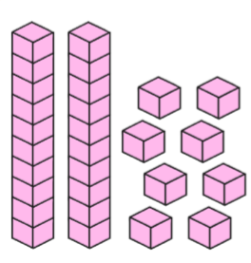 | twenty | 12

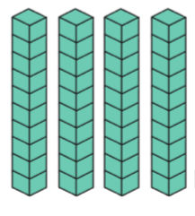 | fourteen | 40 + 1 | 44 | 15

ninety |  | 2 tens  9 ones | 91 | 20 + 8

50 | 10 + 5 | fifty three | 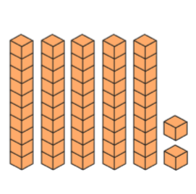 | 5

31 | 30 + 3 | thirteen | 30 | 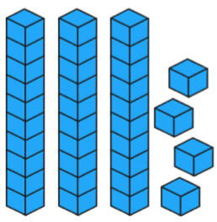

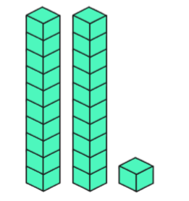 | 20 | 12 | twenty two | 10 + 1

