**TREVERBYN HOME LEARNING ACTIVITIES 9**

Hello everyone. I hope you are all well. It has been lovely to see a few more children at school. I hope you are all working hard and being good for your grown-ups.

**ENGLISH**

**DESCRIPTION IN STORIES.**

When writing stories it is important to use description. You can do this by using adjectives. You could use just one adjective but try the power of three. This is where you use three adjectives. Remember to put a comma between the first two adjectives and “and” before the last one. An example would be… In the cold, dark and gloomy cave. Now you try it. Write descriptive phrases using the power of three about the following:

A car

A bike

A horse

A beach

A forest

A football pitch

A school

A shop

A garden

A pet

**STORY WRITING**

The story below is a really boring story. It would be good if you could improve it. Try adding much more detail. Who did you go with? Was it a nice day? You don’t have to lose a football, you could lose anything. Include lots of description, (don’t forget the power of three), and finish on the same cliffhanger.

One day as I was playing on Bodmin Moor, I lost my football. It rolled under a gorse bush. When I went to get it I found a cave. I went in. The cave was dark. There were bats. It was wet. I went further and found a stream running through the cave. On the other side of the stream I could see something shining. It was…

**SPELLING SHED**

This is updated every week. Year 3 have ‘sc’ spellings this week. See if you can find out what the definition of each word is and then write it in a sentence. Year 4’s can you do the same with your ‘phon’ and ‘sign’ word family words?

**READING**

Read daily. A reminder that the library is launching their Summer Reading Challenge on line. This year’s theme is Silly Squad, a team of animal friends who love to go on adventures and get stuck in to all different kinds of funny books.  For 2020 it’s all about funny books, happiness and having a laugh!

The **Summer Reading Challenge** combines **FREE** access to books with fun creative online activities. This year it has been extended and will be launched on Friday 5th June and run until mid-September. You can find out more and sign up by going to <https://summerreadingchallenge.org.uk/>. Let’s make Tracee happy by signing up and show her we are thinking about her.

**MATHS**

**FRACTIONS**

**ADDING AND SUBTRACTING FRACTIONS**

This week at school we have been working on adding fractions. If the denominator is the same simply add the numerator.

3/8 + 4/8 = 7/8

Try the attached questions. If you end up with an improper fraction, and you will, see if you can turn it into a mixed fraction. For example if your answer is 16/9 you need to think about how many ninths make a whole. There are nine ninths in a whole and then there are 7 more left. This means the answer would be 1 and 7/9

5/8 + 7/8 = 12/8 = 1 4/8

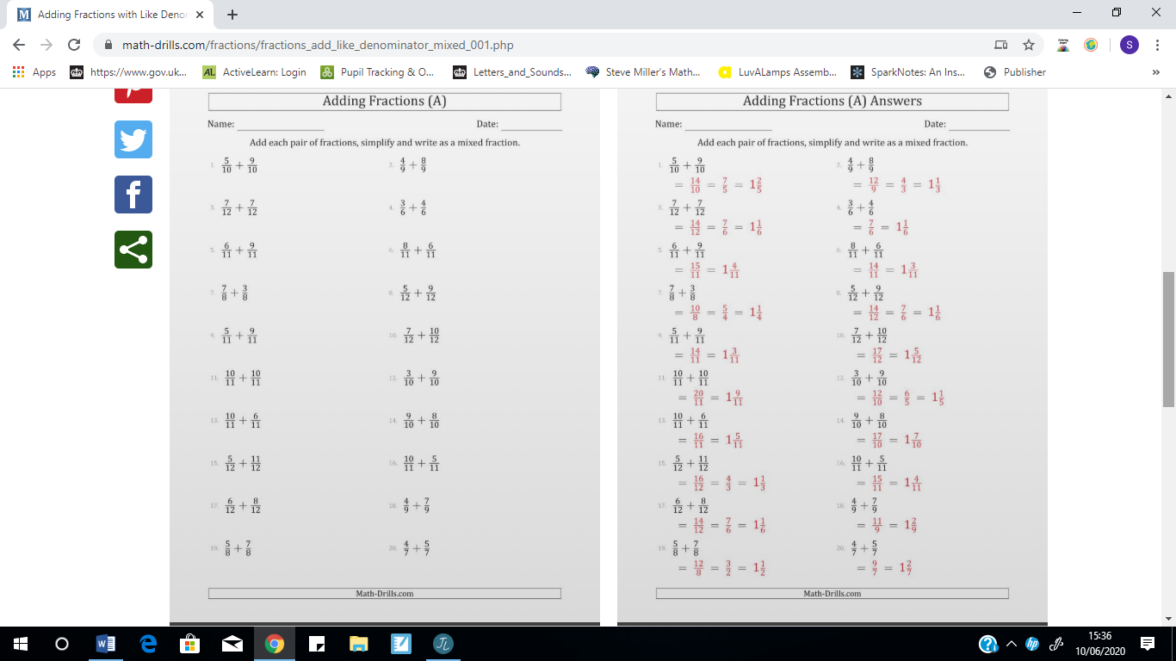

**EQUIVALENT FRACTIONS.**

Roll two dice to create a fraction. Remember to put the bigger number as the denominator. For a fraction to be equivalent, whatever you do to the numerator you do the denominator. Now create equivalent fractions by multiplying the numerator and denominator by 2, 3, 4, 5, 6 and 8.

For example if you roll a 6 and a 4 you will make 4/6.

|  |  |  |  |  |  |  |
| --- | --- | --- | --- | --- | --- | --- |
|  | X2 | X3 | X4 | X5 | X6 | X8 |
| 4/6 | 8/12 | 12/18 | 16/24 | 20/30 | 24/36 | 32/48 |
|  |  |  |  |  |  |  |

**TT Rockstars.**

Try to go on this at least three times during the week.

**GEOGRAPHY**

We have been learning about the structure of the earth. Did you know the crust of the earth can be up to 90km thick? Find out about what the earth is made of. Can you create a model of the earth showing a cross section? You could use playdough, junk or natural materials. If you make a model it would be good if you could send a picture to Dee at [secretary@st-neot.cornwall.sch.uk](mailto:secretary@st-neot.cornwall.sch.uk).

**PE**

I hope you are keeping active. Exercise is important for your physical and mental health. Joe Wicks is continuing his workouts or you could cycle, walk, bounce or skip.