Colours

Literacy

Can find a book with colours or a rainbow in it, can you name the colours in the book or in a rainbow?

Find a story with colours in it e.g. Elmer Colours or Brown Bear, Brown Bear What Do You See?

Can you find a colour starting with the same letter sound as your name?

Maths

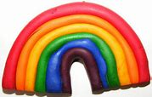
Count how many colours are in a rainbow?

Sort crayons, pens and pencils into their colours?

Can you make a house with Duplo or Lego?

Physical Development

Can you put on your own shoes?

Have you tried holding your pencil between your thumb and two fingers when you draw or write?

Follow the instructions from Action Songs or Rhymes on CD or online with adult support

Communication & Language

Colour hunt can you find and name different coloured objects at home either inside or outside?

Ask members of your family which are their favourite colours.

Learn a new song or rhyme with a colour in it.

Personal, Social & Emotional Development

When out walking with your family see what colours are in the environment look all around you.

Helping at home may be feed a pet or tidy your toys.

Phone or Skype family members to brighten their day, sing them a song or nursery rhyme.

Expressive Art & Design
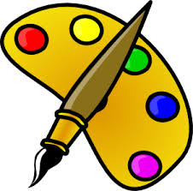
Create a colour collage using different materials or paper

Make coloured ice cubes or lollies (Using squash)

Explore mixing colours together to make a different colour

Understanding the world

What are the primary colours, the colours we can’t make?

Compare similarities and differences between family members (colour of eyes and hair)

