Sugars in food

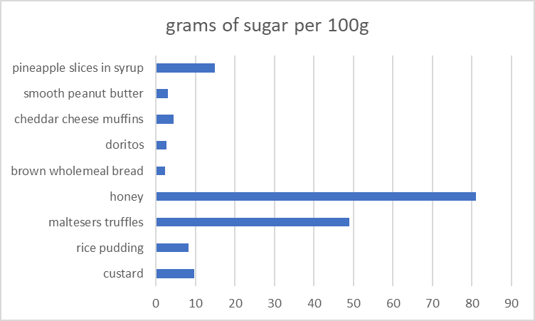

Food | grams of sugar per 100g
Custard | 9.8
rice pudding | 8.3
Maltesers truffles | 49
Honey | 81
brown wholemeal bread | 2.4
Doritos | 2.7
cheddar cheese muffins | 4.5
smooth peanut butter | 3.1
pineapple slices in syrup | 15

Conclusions
- Doritos aren’t sweet, so it was surprising that they contain sugar.
- The honey had the most sugar of everything we looked at.

