TREVERBYN HOME LEARNING ACTIVITIES 12
Hello everyone. It’s been another busy week at school. We have had earthquakes and Tsunami’s in Treverbyn but somehow we all survived. I hope you are all well and working hard as well as having fun.
ENGLISH
STORY
We have being learning about the legend of the Cheesewring. Read the legend, act it out and then re-tell it in your own words. I have included the legend at the end of the home learning.
DESCRIPTION
In the Cheesewring legend there is a giant called Uther. Write a paragraph describing him. Think about what he looks like, sounds like and smells like.
DICTIONARY WORK
There are a few tricky words in the Cheesewring legend. Look up the following words and write a definition, after you have put them in alphabetical order.
wring, folly, amicable, wary, nominate, dominate, hurled

SPELLING SHED
This is updated every week. Year 3 have ‘sion’ words this week. Can you put the words in alphabetical order. Year 4’s you have challenge words. How many of these can you put in a sentence and it still make sense?
READING
Read daily for at least 15 minutes. See if you can find a version of the story of the Giants Causeway and read it.

MATHS
PERIMETER
The perimeter is the distance around the outside of a shape. To find the perimeter add all the lengths of the sides together. For example, a square has 4 sides. If each side measures 6 cm the perimeter would be 6+6+6+6=24cm
Calculate the perimeters of these regular shapes from the length of one side.
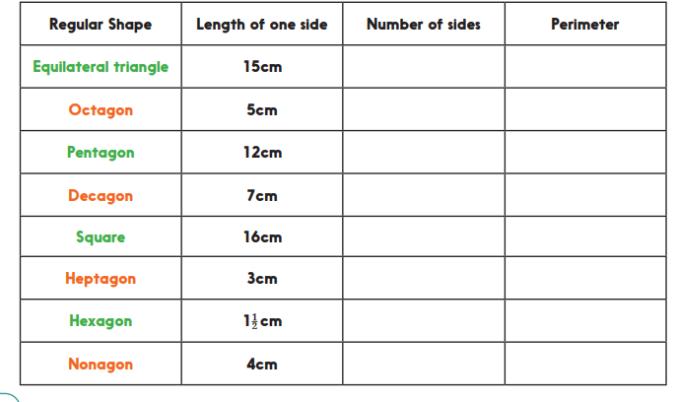
Challenge
What would the lengths of the sides of the following regular shapes be if the perimeter is 30cm:
a. equilateral triangle b. square c. pentagon d. hexagon
Can you suggest 5 different possible side lengths for an irregular pentagon with a perimeter of 40cm?

Calculating the perimeter of rectangles by doubling
Calculate the perimeters of these rectangles from the length of two sides. Remember to find the total and double.
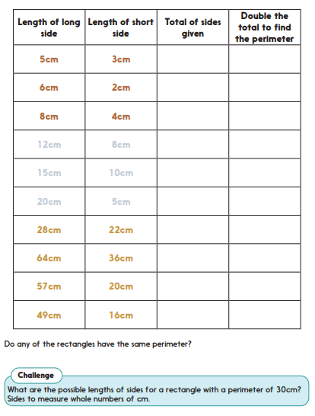
TT Rockstars.
Try to go on this at least three times during the week.

SCIENCE
This week we have been looking at soil. If you can get two or three different samples of soil. Conduct two investigations. First look closely at the soil. Scientists can learn a lot just by observing. What does your soil contain? Make a list of the things found in your sample. Next conduct the following experiment. Write up your experiment including a list of equipment, a method and a labelled diagram.
Soil Shake up
Look at the soil samples. Think about how they are different. Write some notes to describe each one. A good way to compare different soils is by doing a soil shake up.
1. Spoon soil from one of the samples into a plastic jar that has a well-fitting lid
2. Continue spooning until the jar is a little more than half full
3. Now carefully pour water into the jar until it is almost full
4. Screw the lid on tightly and shake the jar to mix up the soil and water
5. When it has had a good shake, put the jar on the table in front of you and allow the contents to settle
What do you notice happening? (scientists observe and make careful notes)
Why? (scientists always ask themselves this question)
Look carefully at the layers you can see in the jar. Draw, colour and label them. Write down anything you notice.
Repeat with another sample.

ART
Use a pencil and paper to sketch the Cheesewring. Really think about the shape of each stone and make sure you use all the space on your paper. Don’t forget to include the background. You could try making your own miniature version of the Cheesewring with stones found in your garden.

The Legend of the Cheesewring.
It was at the time when Christianity had not been long in Cornwall. Saints built stone houses over the wells and declared them sacred and scattered the fields with stone crosses. You would have perhaps expected the people to be wary of the incoming faith. Instead, they began to bring the saints gifts of fish on Fridays. This gesture of acceptance angered the giants who had dominated the lands for centuries. Giants were not fond of stone crosses or the occupation of the wells by men, and they were especially irritated by the taxes charged by the saints for the use of the land. Giants were used to stomping over whatever ground they pleased, and hurling whichever rocks they pleased, carved with a cross or no.
At that time the strongest and most fearless giant was named Uther and the giants nominated him for the task of ridding Cornwall of saints. They called a council of giants up on the high moor. It was a damp day and dark clouds gathered, soon the marshes would spread and the mist fall. Not the day for a small and weak chested saint to venture amongst the gigantic muddy boots filling the moor. When Uther spied tiny St. Tue weaving his way bravely toward him, he felt a surge of generosity. He lifted St. Tue onto the palm of his hand so they could enter into council.
Now, St. Tue had climbed many steep hills on his way to the Giant Council, and all the way he had been considering a plan. He breathed deep in his tummy and forced himself to look up at the hideous giant.
‘I come with a challenge for you mighty Uther,’ he said.
Uther smiled down at the tiny saint who dared challenge the greatest giant. ‘I will hear your challenge,’ Uther replied, feeling amicable.
‘I challenge you to a duel of strength,’ St. Tue replied.
There was a rumble of muffled thunder ribbing across the moor as the giants passed the message of the tiny saint’s folly.
‘And what of this challenge St. Tue?’ Uther asked him.
‘If you triumph you will rid the land of saints in one fair contest. If I win, you and all the other giants present across Stowes Hill and Craddock Moor shall convert to Christianity. For there is one The Almighty who is stronger than you all’
Now, all the giants of the land were gathered at Uther’s council and not one believed this to be a challenge to be lost. For each giant considered himself to be incredibly strong and each knew Uther was the strongest of them all and therefore very, very strong indeed. St. Tue on the other hand, was visibly frail even for a saint and they had never seen any saint looking all mighty. The giants all loved throwing rocks. They began to feel quite cheerful at the prospect of a hurling celebration.
The terms of the contest were agreed. There were to be twelve quoit sized rocks, six each. These were to be hurled across Craddock Moor and onto Stowes Hill. The giants delighted in finding the biggest rocks they could, and St. Tue said nothing in protest. When the rocks were gathered ready, Uther picked up the first rock and hurled it as far as he could up onto the hill. St. Tue looked down and put his hands against either side of the next rock. It felt cold and damp, St.Tue was sure his skin would graze as he tried to lift the grey and unforgiving weight. Drawing upon his faith, St. Tue was amazed for the stone felt light as a feather. He held it, balanced and aimed to place the stone upon Uther’s. There were shouts from the giants and then they turned to encourage Uther to get on with his next piece. Uther threw it easily and a third stone balanced on the pile. St. Tue took his stone more confidently and they continued until the two largest stones remained.
Uther had only to throw the thirteenth and spare stone and he would rid Cornwall of saints forever. It was a very heavy stone, and Uther knew his strength was spent. He took the boulder and threw it anyway, and it hit the side of the hill and rolled down. The giants roared in anguish. Then it was St. Tue’s final throw, Uther had his part completed. St. Tue balanced his stone, and the giants roared louder, trying to unsettle the small saint. St. Tue gathered all his small strength and as he lifted the stone an angel came and held it for him, balancing it ever so carefully on top of the pile with his beautiful golden wings. The giants saw a strong ray of sunlight break through the clouds and light the moor all about the strangely balancing heap of stones, a rock pile crowned with St Tue’s last stone. Christianity was here to stay in Cornwall.
Uther was so amazed that he asked St. Tue to baptize him there and then. The other giants took a little longer to accept the results of the contest. Some were baptised, but many others chose to leave Cornwall to the saints.

