Home Learning Tasks

Seas and Oceans

English

1. Think of an animal that lives under the sea. Write a set of questions relating to the animal that you would like to know the answer to. Don’t forget to use a capital letter at the start of each sentence and a question mark at the end. Ask an adult to help you find the answers to your questions using non-fiction books or the Internet. Can you find out any other interesting facts about your chosen sea animal? Create a fact sheet about your animal using facts and labelled pictures.

2. Investigate dangerous sea animals. What animals are the most dangerous? Where do they live? What makes them dangerous? Create an information booklet to let people know about these sea animals. Use titles, pictures, drawings, labels, text boxes and facts to make your booklet really interesting.

3. Write an Under the Sea adventure story. Who is the main character? What would happen in the story? What animals might you want to include? Remember, most stories have a problem and a solution! Be as imaginative as you can and remember the rules of writing:

* Use a capital letter at the start of every sentence and for names of people and places.
* Use a full stop at the end of every sentence.
* Use a clear finger space between each word and keep your writing neat and on the line.
* Sound out words carefully using phonic sounds (see the sound boards on the second page).

4. Continue to practise spellings on Spelling Shed. These will be updated weekly and will contain new spellings and some from previous weeks. If you would like extra spelling practise, look at the Common Exception Words on the following page, making sure to choose the correct list for your year group. Practise spelling these words as much as possible, using different strategies to help remember any unusual spellings.

Maths

1. Practise reciting the days of the week. All children should be able to chant the days in order. They should also be able to answer questions about the order and relationship between the days. For example: What day comes before Monday? If today is Friday, what day will it be tomorrow? Please practise spelling the days of the week as well, remembering to use a capital letter at the start of each day. Write the days of the week on paper and cut them up into cards. Take turns turning over the cards. If, when you turn the card, you have a day that is before or after the day shown you can say snap.

2. Continue to practise writing numbers up to 100. Ask an adult to say a number. Can you write it in digits and in words? As an extra challenge, ask an adult to say a three digit number. For example, three hundred and twenty five. Can you write the number correctly in digits (325)?

3. Can you identify odd and even numbers? An even number can be shared into two equal parts (with no remainders) but an odd number cannot. We often remind children that even numbers end with 0, 2, 4, 6, or 8 while odd numbers end with 1, 3, 5, 7 or 9. Remember to look at the number of units that a number has; the number at the end! Once you are feeling confident, ask an adult to point to a number on the hundred square on the following page. It is an odd or even number? How do you know? If you are feeling brave, ask an adult to say a three-digit number. Can you decide whether the number is odd or even?

4. Practise your number facts using Hit the Button (a free maths game which helps to improve recall of number facts). Search Hit the Button for free on Google. Focus on number bonds to 10 and 20, doubling and halving and times tables. How many questions can you get right in 1 minute? Record your best scores!

5. Continue to practise your recall of multiplication and division facts using Times Table Rock Stars!

Topic

1. Look at the beach safety poster on the following page. What dangers can you see? Explain to an adult what you notice and why you think that it is dangerous. Talk to an adult about how to stay safe around water (including swimming pools and beaches). Create a poster to explain how to stay safe. Remember to use a title, images and text to make your poster eye-catching.

2. In recent years, there has been a focus on the amount of plastic in our oceans. Work with an adult to find out about the extent of plastic pollution in the World’s oceans. What do you think we could do to help reduce the amount of plastic?

3. Look at a map of the World. Can you find the World’s five oceans (Atlantic Ocean, Pacific Ocean, Indian Ocean, Arctic Ocean and the Southern Ocean)? What other seas can you find on the map?

4. Use your imagination to create an under-the-sea animal made from objects around your house. It can be a collage, a drawing/painting or a junk model. Don’t forget to send us a picture so that we can see your artistic creations!

Other Activities

1. Watch BBC Newsround and find out what is happening in the world. What did you find out? Is there anything you need help understanding?

2. Practise getting changed as quickly as possible. Ask an adult to time you, as you get dressed. This includes putting on socks, shoes, a jumper and a coat. How fast can you get ready? Create a scoreboard and record your fastest times!

3. Read as much as possible. Call a family member or a friend and read a book to them on the phone. Remember to use expression and pause for full stops! There are lots of books available to read online. For example, on the Oxford Owl website or as PDFs.

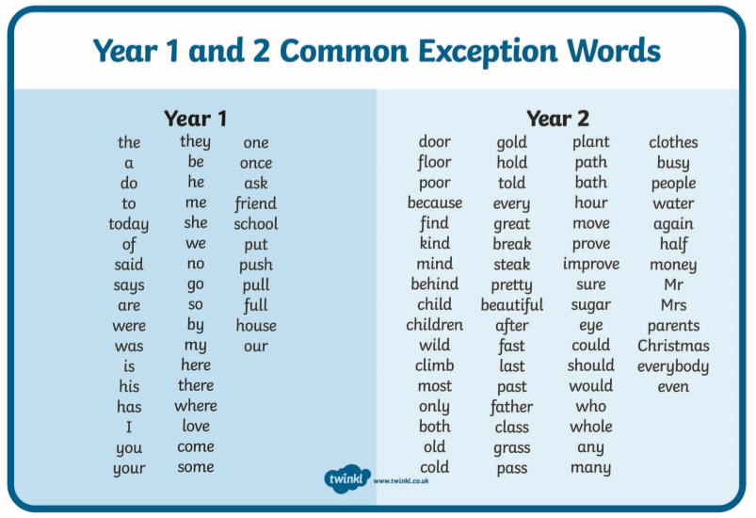

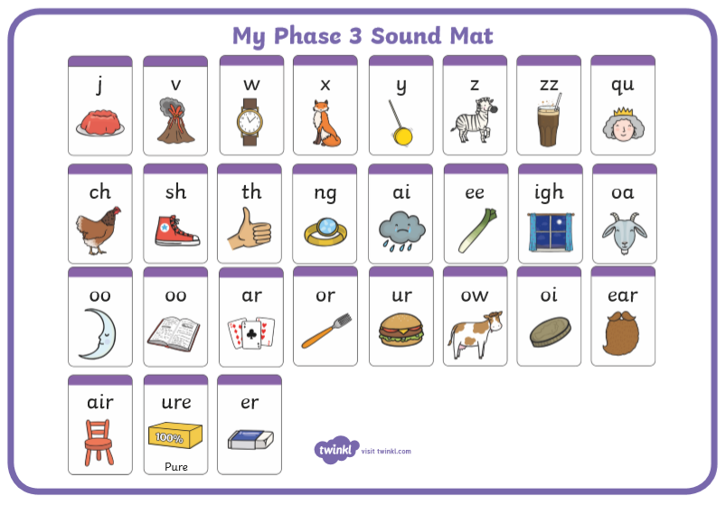

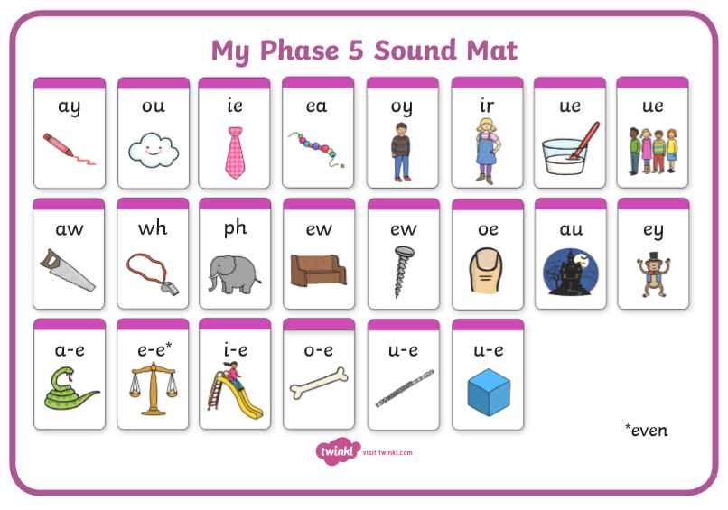

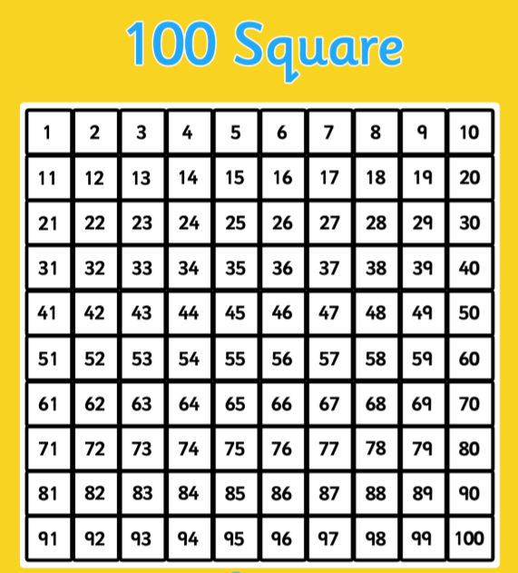

[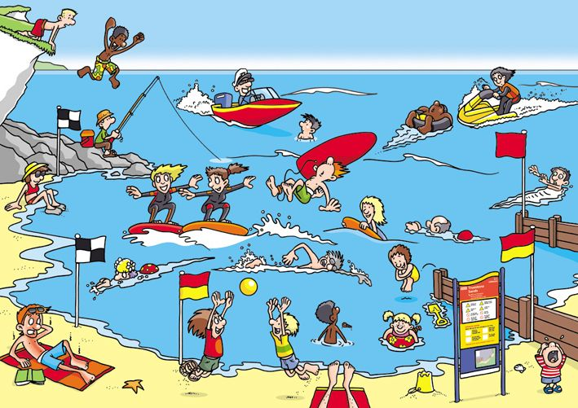](https://www.google.com/url?sa=i&url=https://www.pinterest.co.uk/pin/464855992769784996/&psig=AOvVaw1kCmlWhoobAE2fL5tU32Gi&ust=1588935981856000&source=images&cd=vfe&ved=0CAIQjRxqFwoTCJC-8PjNoekCFQAAAAAdAAAAABAD)