In The Garden
Literacy
Create a sunny picture using finger painting, crayons or bubble painting
Read a book together, does it have a picture of the garden, can you find the sun in your book, is there a flower?
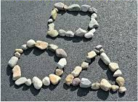
Using water and a paint brush paint the fence or wall, using up and down movements.

Maths
Find shapes outside.
Find stones and put them in order of size.
Count the number of stones you have found. How many trees are in the garden? How many different flowers can you count?
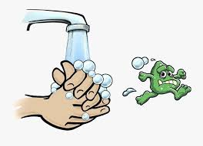
Physical Development
Five star jumps every day.
Kick a ball to and fro to someone in your family.
Wash your hands when you come in from outside. Sing happy birthday twice whilst doing this. Don’t forget those thumbs and nails. Advice on NHS website.

Communication and Language
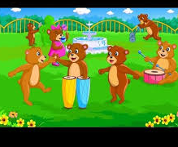
Recite nursery rhymes with a member of your family:
Mary, Mary Quite Contrary
Round and Round the Garden
Jack and Jill went up the Hill
Talk about what you can see in your garden
Personal, Social and Emotional Development
Make a mud pie outside
Take a photo of your family in the garden
Ring a grandparent or friend and tell them about what you have found in the garden.
Expressive Art and Design
Whilst outside find a stick and tap it against objects to explore sound.
Dance around the garden singing the nursery rhymes you have learnt.
What can you go under and over?

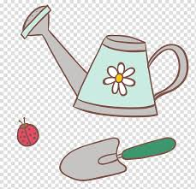
Understanding the World
Look at and listen to the birds.
Find objects to sink or float in a bowl outside.
Water plants.

