Fowey Class Home Learning Activities – Tasks 2

Year 6 Revision Book
Although you won’t be sitting Key Stage 2 SATs, your revision books are an excellent way to prepare for secondary school. I cannot encourage you strongly enough to maintain your hard work and discipline.
Reading – page 16
Maths – page 17 and page 46
SPAG – page 22, page 56 and page 76

Year 5 and 6 Project
The project this week is based on your local area and surroundings. During your project, you will use investigation, writing, mathematics and creative skills. I would like you to explore and investigate (either in person, online or from memory) your local area and create a presentation, this can be written, a display or a PowerPoint.

Reading
Reading is vital. Please continue to read plenty of texts and try to read a wide variety of genres. If there’s anything you find tricky, either research it or ask an adult for help.

Spelling
Please access Spelling Shed; the assignments are updated regularly. Only five children were on last week.

Writing
- Thinking about your local area, you could create an information leaflet about the places you think a visitor to your area should go. You should include headings, paragraphs, pictures, captions and extra facts.
- Imagine a stranger moves into your local area, create a character description of your stranger. They could be friendly or threatening. Describe the character’s personality, strengths and weaknesses as well as their appearance.
- You could also write a poem using rhyming couplets that describes a particular place in your local area.

Maths
- Use cardboard and a pencil to create your own number spinner with the numbers 0-9 (see below). Use your number spinner to generate a 2-digit number. What are the factor pairs of your number (what can it divided by) and what are the next three multiples of your number. Repeat this several times.
- Use your number spinner to generate large numbers to practise column addition and column subtraction.
- Create nets for 3D shapes and fold them to create the shape. Try to create a cube, cuboid, triangular prism, square-based pyramid, tetrahedron (triangular-based pyramid), cone and anything else you would like to do.
- Don’t forget TTRockstars, only one person from Fowey class has been on in the last three weeks!

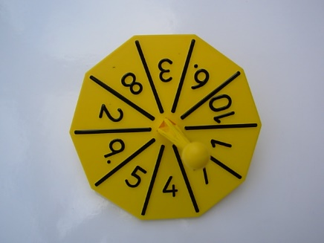

Science
Investigate how the moon appears to change shape during the week. Take photographs, draw sketches or research the moon’s appearance each night and describe the changes, can they give reasons for the change? You could also look at different constellations, draw pictures and identify their names. Can you create your own constellation?

Art and Design
Collect objects from around your area and use them to create a collage that shows what your home or garden looks like. Try to use a variety of textures and shapes to add interest. If you can, take a photo and email it to school so I can create a class collage of your creations.

Physical Education
I strongly advise regular physical exercise every day to help keep you fit and feeling well. Can they create their own games using household or garden objects? In school, we do Joe Wick’s workout every day; it’s great fun!

Please feel free to share any of your hard work and creations with us in school; we’d love to know how you’re getting on. Send pictures or files to us using secretary@st-neot.cornwall.sch.uk

