Home Learning Tasks
Food
English
1. Write a set of instructions for making a cup of tea or some toast. Remember to write a list of the objects and ingredients that you will need at the start. Then write numbered steps, using imperative verbs (words which give a command) explaining exactly how to do your chosen task. Make sure your step-by-step instructions are detailed and don’t miss out any parts of the process.

2. Create a shopping list for the week. What does your family need? What “extras” would you add to the list if you had the choice? Ask an adult to help you group the items on your list according to their food group. For example: fruit, vegetables, meat, dairy…

3. Write a poem about your favourite food. Can you make it rhyme?
4. Draw pictures of all the fruit and vegetables in your house. Make sure you label them carefully. Can you put the items in to alphabetical order? What happens if two items begin with the same letter?
5. Continue to practise spellings on Spelling Shed. These will be updated weekly and will contain new spellings and some from previous weeks. If you would like extra spelling practise, look at the Common Exception Words on the following page, making sure to choose the correct list for your year group. Practise spelling these words as much as possible, using different strategies to help remember any unusual spellings.

Maths
1. Look at the 2D and 3D shapes on the following page. Can you name all of the shapes and recall some of their properties? For example: A square has four straight sides of equal length. Look around your house and make a list of the 2D and 3D shapes that you can find. Can you find an object to match every shape? Create a “Shapes Around My House” poster, labelling the objects and the related shapes.

2. Practise recalling doubles of numbers from 0 – 10, extending to doubles between 10 – 20 (although these are a lot trickier). Remember that when you double a number, you have to add same number twice. It is two “lots” of the same number. You should be able to recall doubling facts from 0 – 10 quickly, but this takes practise. How many doubles can you recall in 30 seconds? Record your best score and let us know! If you would like an extra challenge, ask an adult to explain how you can use your knowledge of doubling numbers between 0 – 10 to double multiples of 10 up to 100. For example: 2 + 2 = 4 20 + 20 = 40
3. Look at the tally chart and bar chart template on the following page. Think of six different types of fruit and write them above each column of the tally chart. Ask your family to choose their two favourite fruits and record this as a tally. Once you have enough data, ask an adult to help you complete the bar chart to represent the information in the tally chart. Afterwards, use the bar chart to help you answer the questions.
4. Practise your number facts using Hit the Button (a free maths game which helps to improve recall of number facts). Search Hit the Button for free on Google. Focus on number bonds to 10 and 20, doubling and halving and times tables. How many questions can you get right in 1 minute? Record your best scores!
5. Continue to practise your recall of multiplication and division facts using Times Table Rock Stars!

Topic
1. Can you design a new school menu for a one week period? You will need a main meal (with sides) and a dessert for each day of the week. Think about the meals that you usually have at school. What would you add to the menu? What would you keep the same? Will it be a healthy school menu? Draw pictures to go with your menu choices and remember to make them look appetising!
2. Ask an adult to help collect a range of different foods from the kitchen (fresh, tinned, dried and frozen). Sort the foods into “healthy” and “unhealthy” foods. Are there any foods that fall into both categories?
3. Look at the artwork of Italian artist Giuseppe Arcimboldo. He was well-known for creating portraits made entirely of fruit and vegetables. Can you create your own Arcimboldo-inspired artwork using different types of food? Make sure you take a photograph of your artwork and send it to us!

Other Activities
1. Watch BBC Newsround and find out what is happening in the world. What did you find out? Is there anything you need help understanding?
2. Help an adult with the household chores. Can you help with the dusting or loading the washing machine? Make a list of all the things that you have been helping with (including photos if possible) and let us know how helpful you have been!
3. Read as much as possible

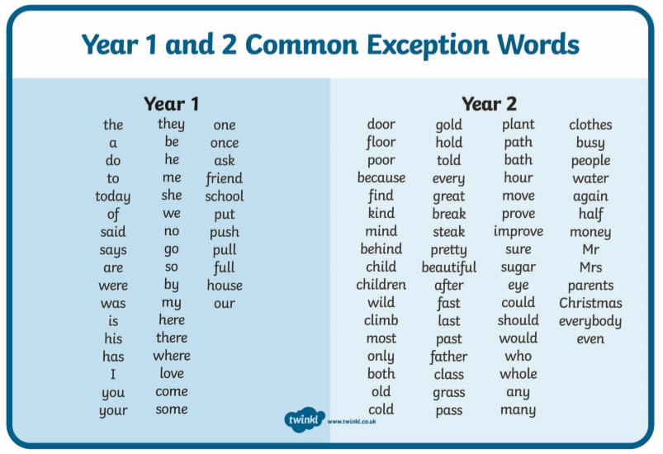

2D Shapes
