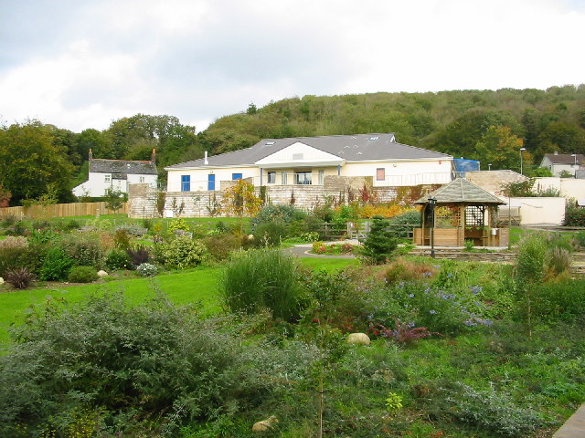
ST NEOT COMMUNITY PRIMARY SCHOOL AND NURSERY

Self-evaluation summary

January 2022

Self-evaluation summary St Neot School and Nursery 908-2719 Ofsted number 111964

The context of the school
References to the current School Development Plan are referred to as SDP.
St Neot is a rural primary school and nursery for children aged 2-11 having approximately 124 pupils. The school is situated in a mixed income area serving many families whose social circumstances are less favourable than national averages.
The village is a scenic place on the edge of Bodmin Moor with mixed housing, mainly high cost private, but also local authority and housing association. There are problems associated with rural deprivation, the percentage of pupils in the school living in the most deprived 30% of small areas in England is 8.5% compared to a LA average of 32.1% (Corestats 2018 pg1).
The intake represents a cross section of the community coming from a wide area, some children travelling considerable distances. There are a relatively low proportion of ‘professional’ families, being an estimated 26% during 2020. An estimated 10.6% of families live in rented accommodation. 7.7% claim free school meals though we believe there are a considerable number who don’t claim.
- The Covid-19 pandemic has caused economic hardship for many households. In Cornwall as a whole, unemployment benefit claims have increased by 3.5% (Corestats)
- Mobility is usually high, although this varies from year to year; for example from Jan 20-Jan 21 mobility was 10.67%
- The proportion of children requiring additional support is generally average although this too varies from year to year. Across the school 2% of pupils were identified as having special needs with an additional 1 pupil with an Educational Health Care Plan
- The most recent analysis of the Index of Multiple Deprivation puts St Neot School in the most deprived 30-40% at 78% for the school and 27% for the nursery (LSOA Indices of Deprivation November 19)
- The region has been identified as having the second highest level of poverty in Northern Europe
- Cornwall is 103rd out of 150 for funding in England, and 144th for high needs funding (HMI March 2019)
- There have been no exclusions in the past year
- There have been no complaints in the last year
- The number on roll from 75 in 2015/16 to 97 in 2021/22
- Attendance was above the national median at 98.02% for 2019-20. Unauthorised absence was 0.32%. 0% persistent absence.
- Gov.uk record 21.3% of possible sessions in the 2020/21 academic year were recorded as not attending in circumstances related to coronavirus. This includes pupils self-isolating and shielding, including when a class or bubble has been required to stay at home, and includes the period of national restrictions in Spring term 2021 when 57.5% of sessions were recorded as not attending. Throughout the pandemic St Neot School opened to children of keyworkers and vulnerable pupils. All other pupils had access to remote learning. Devices were circulated to all pupils who were unable to have access to devices for countless reasons including those with more one child in a family needing academical support.
DISTINCTIVE AIMS AND FEATURES
Our school is committed to "A happy learning environment for all" and the provision of a high standard of education. Within a safe and caring environment, the school aims to provide equal opportunities and to develop the knowledge and skills of each child. The ethos of the school is reflected in feedback received from visitors to school who find the atmosphere to be calm, friendly, hard working, co-operative and professional.
There are excellent facilities and a high level of support from parents and the community. The current building is architect designed and purpose built, being opened in 2003, and extended in 2010 with the addition of a Children’s Centre which has now been handed over to the school and which accommodates the Nursery. A kitchen and extra storage room was added in 2014, and an extension to the building was completed in December 2019, providing additional classroom space.
AIDS TO RAISING PERFORMANCE.
- The school is fully committed to a programme of improvement (School Development Plan) to provide a varied and enriched curriculum
- A broad and balanced curriculum, and a variety of extra curricular activities across the age range
- Excellent provision at transition points giving support to ‘mobile’ pupils as well as at Foundation and KS2/KS3
- Pupil Premium Provision is successful in providing a full and varied level of support which is reflected in the cohort data
- The Sport Premium has enhanced a range of opportunities for all pupils to participate in a range of activities and performances. Staff have also upskilled to provide quality lessons
- Creative and musical opportunities are a feature of the school including whole school/community events
- Exceptional provision for children's spiritual and moral development through a whole school learning ethos, interesting RE and PSHE, high quality provision for worship and ‘global awareness’ days
- Parents provide good or better support for home learning e.g. all families attended parent consultation evenings in the autumn and spring terms
- Excellent use of external agencies (School Improvement Partner) to identify areas of strength and weakness and to provide appropriate support
- Commitment to partnership within the Liskeard Cluster of Schools
- Status as a maintained school providing a breadth of support
- High priority to staff development, in particular to the development of teaching and learning
- Highly qualified staff work as a team, providing an excellent role model for pupils
- Weaknesses and strengths are identified for development with a culture of improvement amongst the staff and governors, e.g. SDP priorities are set, governors challenge during meetings, CPD

Pupils’ achievement
The most recent inspection graded achievement as outstanding.

Evidence supporting this judgement:
- APS scores show standards are excellent overall with consistent results above or in line with the National Averages in English, Maths and Science at both key stages
- Pupils demonstrate achievement significantly and consistently above the National and County Averages
- Lesson observations and book scrutiny show evidence of progress
- School Development Plan 19/20 gives priority to identified need, enabling the whole school to work together to improve the areas with the greatest impact on children’s learning. These include:
- Quality of Teaching
- Standards and Achievements
- New National Curriculum Achievement of Pupils
- Effectiveness in Early Years
- Pupils’ Independent Skills in Foundation Subjects
- Minority Groups and SEN
- Development of Sport, PE and Healthy Lifestyles
- Leadership and Management
- Behaviour
- Health and Safety

Attainment at KS2
- 2019/20 excellent progress achieved for a lower ability cohort, who were scrutinied throughout their primary education.
- Achieved above national and local combined score:
Year 6 Sept 2020 – July 2021

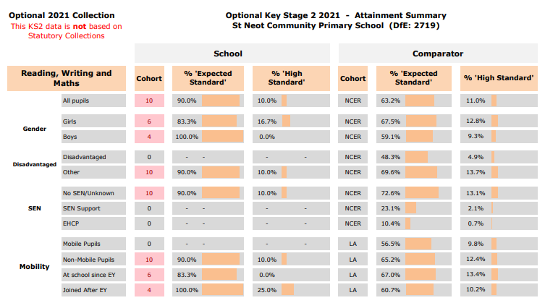

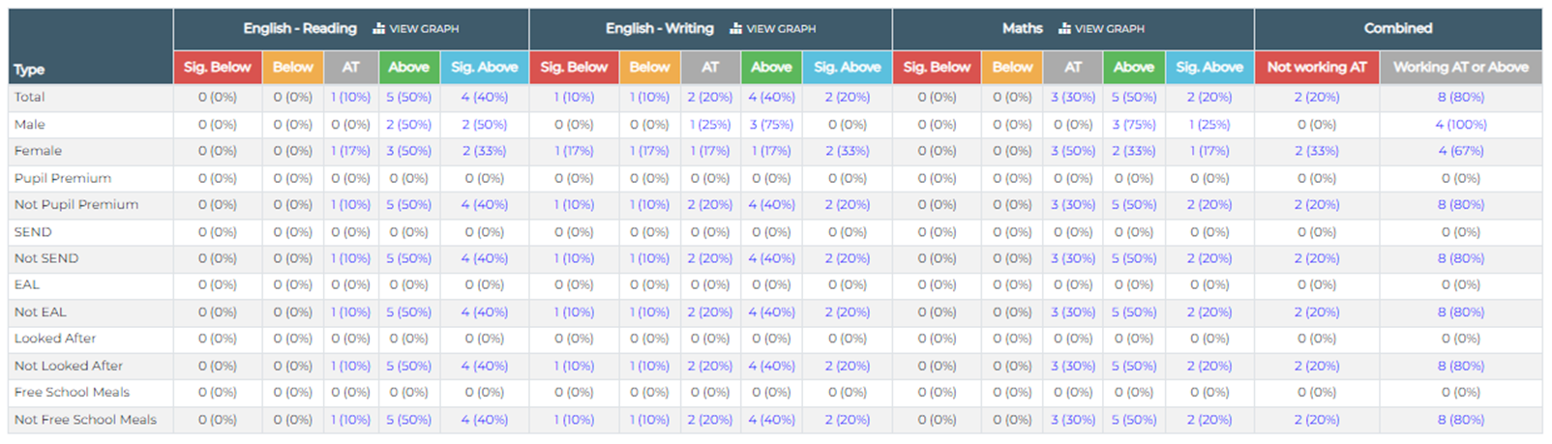

Attainment Strengths at KS2 (2020)
- Cohort percentage score above DfE comparator
- In reading, writing and maths boys scores were above girls
- Average scale score for boys and girls in reading and maths were above DfE comparator
- In GPS tests girls scored just above average, boys just below by 0.5%
- Overall performance 13 out of 252 schools in Cornwall

Attainment at KS1
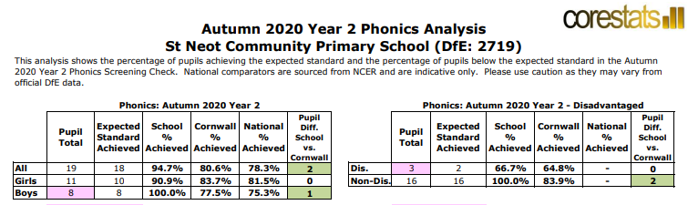
- 94.7% of Y1 pupils met the expected standard in the phonics screening check , above national average of 78.3%
- Writing, reading and maths at KS1 is above national average

Year 2 Sept 2020-July 2021

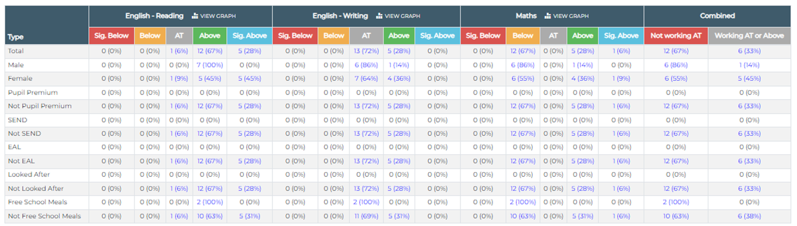

Attainment at EYFS
The children individually make significant progress and are consequently able to move into KS1 with confidence.

EYFS Profile | Boys (7) 2019 | Girls (10) 2019 | All 2019
Reading | 100% | 100% | 100%
Writing | 100% | 100% | 100%
Numbers | 100% | 100% | 100%
GLD | 100% | 100% | 100%

We know this because:
- Foundation Stage provides a well planned curriculum which enables the children to learn and make an outstanding level of development from EYFS.
- Overall Foundation Stage profile scores above LA/National averages and children make expected or above progress in each of the 17 aspects.
- Parents provide appropriate support for their child's learning with support and encouragement from staff
- There is sound teaching of basic skills across the curriculum and a clear overview of the standards to be achieved at the end of the Foundation Stage
- Learning Journal records are comprehensive
- Smooth transition form Nurdsery into Foundation provides accurate details of progress
- Boys and girls make at least the expected level in all developmental areas
- Nationally in 2020 72% of children achieved a GLD, the Cornwall average was 70.3%

Mobility/Vulnerable children
Mobility is a significant factor in the school (for example 5.7% in 2013/14, 12.5% in 2014-15, 26% in 2015-16, 10% in 2016-17, 2017-18 12.3%, 2018-19 12.4%). Pupil tracking shows ‘mobile’ children made excellent progress

The following indicate excellent provision for SEND:
Of children on roll on the Provision Map
- Average Point Score Improvement of 1.6 18/19 at KS2
- Support is actively managed using detailed provision mapping
- Provision is well funded with qualified teaching assistant support in all classes
- Child with EHC Plans have outstanding provision-extra funding for SEN has been provided from the school budget-a creative curriculum is used and excellent progress is made
- Intervention supports learning

Key Stage 1-2 Progress and attainment
English
ALL PUPILS |  |  |  | DISADVANTAGED
Year | Cohort | Average Scaled Score | Average progress score | Year | Cohort | Average Scaled Score | Average progress score
2016 | 10 | 106.7 | 2.89 | 2016 | 2 | 103.5 | 3.01
2017 | 9 | 107.4 | 2.67 | 2017 | 1 | 108 | 1.09
2018 | 10 | 111 | 5.0 | 2018 | 1 | 102.5 | 1.02
2019 | 12 | 105.8 | 1.8 | 2019 | 0 | n/a | n/a

Writing TA
ALL PUPILS |  |  |  | DISADVANTAGED
Year | Cohort | Average Scaled Score | Average progress score | Year | Cohort | Average Scaled Score | Average progress score
2016 | 10 | 50% | -5.63 | 2016 | 2 | 0 | -9.16
2017 | 9 | 88.9% | 0.28 | 2017 | 1 | 100% | -1.49
2018 | 10 | 73% | 0.9 | 2018 | 1 | 100% | -1.32
2019 | 12 | 83.3% | 1.4 | 2019 | 0 | n/a | n/a

Maths
ALL PUPILS |  |  |  | DISADVANTAGED
Year | Cohort | Average Scaled Score | Average progress score | Year | Cohort | Average Scaled Score | Average progress score
2016 | 10 | 106.4 | 2.35 | 2016 | 2 | 102 | 0.33
2017 | 9 | 105.9 | 1.52 | 2017 | 1 | 105 | -1.10
2018 | 10 | 104 | 3.3 | 2018 | 1 | 103 | 0.43
2019 | 12 | 106.5 | 3.1 | 2019 | 0 | n/a | n/a

The quality of teaching
The most recent inspection graded achievement as outstanding.

Evidence supporting this judgement:

Observations of lessons indicate the following:

- 2018/2019: Majority of lessons good/outstanding
- 2019/2020 Lessons continue to be of a high standard supported by a well balanced, broad, comprehensive and progressive curriculum.
- 2020/2021 Learning walks show pupils are engaged and making good/better progress
- 2021/2022 Learning walks whow that lessons are progresseive, pupils show confidence and enjoy learning

High quality teaching meets individual needs and encourages progress:
- Teachers have extensive subject knowledge and plan effectively with appropriate teaching strategies
- Teaching assistants are highly qualified and skilful in supporting learning
- Lessons have clear learning intentions, are understood by pupils and are self-evaluated, enabling learning to be internalised
- Excellent co-operation of class teams, sharing knowledge and learning needs of the children
- Pupil/teacher relationships are exemplary resulting in high levels of concentration during lessons
- A variety of media and approaches utilised to inspire learning
- Teaching is inclusive and differentiated for all groups such as SEN and more able, intervention strategies making a positive difference
- Resources updated to develop a clear progression of understanding.
The high quality teaching promotes quality learning experiences:
Lessons are interesting, supporting and motivating pupils
- Pupils are challenged to do their best and recognise success
- Pupils are attentive and dialogue reinforces learning
- All children have equal opportunities to learn
- Plenaries are targeted to reinforce learning
- Pupils show a high level of interest in their work and understand what they are doing
- Children develop the skills and capacity to work independently and collaboratively
- Teaching is personalised, children working at an appropriate level with account taken of previous learning
- Lessons are at an appropriate pace with clear but flexible planning
- Children demonstrate a love of learning and high levels of interest
- Sport Premium provides quality experiences and is promoting physical fitness
- An outstanding curriculum offered through the identification of rich, collaborative and purposeful learning
- The school promotes the fundamental British Values of democracy, the rule of law, individual liberty and mutual respect and tolerance of those with different faiths and beliefs
- Effective measurement of targets.

Assessment is rigorous and appropriately monitors learners progress:
- Curriculum plans are annotated, weaknesses and strengths followed up
- External testing and moderating ensures standards of learning are outstanding
- Pupils are increasingly involved in their own self-assessment and are aware of own learning
- Individual pupil tracking monitors progress and enables planning for intervention strategies
- Classroom Monitor/Rising Stars used diagnostically
- Reliable and accurate teacher assessments standardisation and moderation of teacher assessments is undertaken.

Learning environment enables children to progress quickly:
- School ethos, ‘A happy learning environment for all’ provides children with a secure context for learning
- High quality physical space enables excellent provision and access for all pupils
- Displays and learning walls reinforce the children’s understanding
- Staff training promotes high quality practice.

Curriculum is challenging and provides a range of opportunities:
- Curriculum mapping ensures provision within and beyond national requirements, being kept up to date to meet the requirements of the New National Curriculum 2014
- Extra curricular activities provide extended opportunities in the arts and sport
- Educational visits are designed to broaden the experiences of the child and develop their self confidence in learning
- Provision of high quality music and drama gives opportunities for cultural achievements
- ICT provision is adapted to provide up-to-date learning opportunities
- Appropriate provision is in place for minority groups including Pupil Premium, CiC, EAL and SEN
- CPD ensures capabilities keep pace with current standards.

Parents and carers are involved in their childrens' learning:
- Homework is used effectively and parents are positively encouraged to be involved
- Staff work with parents to support their childrens' learning as needed
- Regular consultation meetings and communications with parents ensure effective home/school partnership. All families are involved in consultations
- Individual pupil targets are shared with parents
- Positive parental feedback indicates confidence in their children’s learning at school.

Transition:
- St Neot Nursery is on site and transition activities take place effectively throughout the year. This provides new pupils and families with a secure and known environment from the start of their school life and children are able to progress across the Foundation Stage with no or little transition setback
- Transition activities also take place with other providers to ensure an excellent start for all
- Excellent transition arrangements are in place with many local secondary schools to enable pupils to transfer to KS3 with confidence.

Behaviour and safety
The most recent inspection graded achievement as outstanding.

Evidence that supports this judgement:

Safeguarding
The learners feel safe and adopt safe practices to provide a safe environment. Factors which contribute include:
- School’s valued ethos of mutual respect between adults and adults, children and children, adults and children. This underpins the quality of all aspects of the children's learning and development
- Pupils demonstrate they have the confidence to talk to staff if they feel at risk, each child has an identified ‘safe person’
- School has an up to date and fully implemented safeguarding/child protection policy
- School adopts safer recruitment procedures
- Single Central Record is fully implemented and checked regularly by Headtacher and Safeguarding Governor
- Pupil Code of Practice and Staff Acceptable Use Policy provide a safe framework for IT
- Risk Assessments contribute positively to the health and safety of the whole school community
- Behaviour policy is regularly updated to reflect best practice, and bullying is not tolerated. There are clear procedures in place to deal with any allegations
- A mutually supportive environment enables children to be successful learners
- Informal buddy system is put in place for older children new to the school
- Staff are appropriately trained and aware of safeguarding issues
- Safeguarding is evaluated each year to ensure all procedures are properly followed
- Discussions with pupils indicate that they feel they are in a safe environment
- Safeguarding is given prominence on the school website
- School recognises the importance of effective and prompt safeguarding/child protection procedures and the need to work closely with Cornwall Council and MARU
- Parent and pupil surveys indicate high levels of satisfaction with safeguarding in school

Behaviour
The excellent behaviour of the children enables a positive learning environment and high standards throughout the school:
- No lessons are significantly disrupted by poor behaviour
- School has a highly successful behaviour policy which is updated in collaboration with pupils, staff and governors. The policy outlines a clear and comprehensive system for rewards and sanctions. The policy is supported by all staff and the School Council
- Pupils who have behaviour difficulties receive additional support through the special education record of need, details included in IEHPs. There is additional support through external agencies
- Lunch time staff meet regularly and there are excellent lines of communication across the school which identify needs and enables appropriate action to support positive behaviour
- Children are encouraged to talk and listen, and to express their views appropriately
- Defined opportunities for pupil voice through our pupil leadership
- Parent and pupil surveys indicate high levels of satisfaction of behaviour

Attendance
- Attendance was above the national median at 98.02% for 2020-21 (national average 95.3%). Unauthorised absence was 0.32% (national average 0.4%).

Leadership and management
The most recent inspection graded achievement as outstanding.

Evidence that supports this judgement:
Leadership
- School team provides exemplary opportunities for learning that successfully supports the focus on improving achievement and raising standards
- Leadership of the headteacher/leadership team is excellent, being dedicated to the promotion of high standards through challenging targets for improvement and the personal development and well-being of the children
- Our vision permeates everything we do, the headteacher is knowledgeable and reflective, offering a strong role model to staff and pupils, creating a common sense of purpose
- School is keen to take on new innovations which raise standards of teaching and learning
- Procedures and systems are clear and effective, with sufficient flexibility to cope with change and reflecting the focus on raising standards
- Inclusion of all children is central. St Neot School successfully promotes all pupils' learning and helps them achieve well because children believe they can succeed
- Effectiveness of leadership is outstanding in quality of care, guidance and support for learners as demonstrated by the PSHE Inspection in 2007 and continued in the full inspection in 2014. The personal development and well-being of pupils is of a very high quality
- Curriculum co-ordinators set clear, meaningful targets and are fully aware of strengths and weaknesses.

Management
- Targets are set at all levels within the school, from individual pupil targets, cohort and whole school, to performance management objectives for staff. Standards in the school have steadily risen
- Successive strategic plans highlight the drive for continuous improvement as targets for all aspects of the school are pursued
- School is rigorous in its evaluation work. The school successfully monitors and evaluates its own performance. Procedures for tracking pupils' progress are rigorous and an electronic system runs alongside written pupil tracking records
- School examines its performance against its own targets when planning for the future. Priorities are based on rigorous self-assessment taking all factors and interests into account
- Self-evaluation influences the direction of the school. It identifies the priorities for improvement which are built in to the school strategic plan
- School is fully committed to professional development of its staff
- Weaknesses are addressed by setting clear prioritised targets as outlined in the SDP

Resources
The school operates with financial integrity as demonstrated by the annual SFVS Return. There are no shortcomings evident in the management of resources:
- The SLT and Governors have a shared understanding of financial management roles, responsibilities and accountabilities
- School governance arrangements ensure that Governors are able to fulfil their financial management roles, responsibilities and accountabilities
- The School has effective governance arrangements covering issues which include conflicts of interest and protected disclosure.

Governing Board
The Governors are a stable body and operate effectively. They shape the direction of the school, having an understanding of the school's strengths and weaknesses, making a integral contribution to the leadership of the school and offering a range of experience.

They support and challenge the leadership team, keeping in close touch with the work of the school and its drive for improvement:
- Clear process for development including a cyclical development plan
- Governors work effectively in committee holding half termly meetings which monitor the curriculum, finance, staffing and the effectiveness of the SDP. The plan is continually updated to reflect the needs of the school as well as driving the improvement of standards in teaching and learning
- Governor visits monitor progress across all areas of school life and effectively contribute to the maintenance of standards
- Governors are an integral part of the drive for school improvement, questioning policy and standards in the course of meetings and during visits
- Governors provide a wide vision for the school, evaluating all possibilities such as academy status. They believe exploring the changes to status will provide the best opportunities for the children at the present time
- Training is updated regularly
- Governors challenge attainment and set clear targets to maintain outstanding performance
- Governors handle complaints in line with guidance.

Rigorous systems are in place to monitor our performance and its impact on pupils’ learning:
- Performance management systems
- Monitoring of planning
- Scrutiny of work
- Observations of teaching and learning
- Governor visits
- Pupil tracking
- Annual written reports
- Whole school strategic planning and evaluation.

Overall effectiveness, including the promotion of the pupils’ spiritual, moral, social and cultural development
The most recent inspection graded achievement as outstanding.

Evidence that supports this judgement:

Pupils’ spiritual, moral, social, and cultural development
- School offers outstanding provision in personal development, well-being, care, guidance and support as evidenced by a PHSE subject report 2007 and a full report in 2009 and 2014. There was an interim phone inspection n November 2020.
- School offers quality provision in health education and the children develop healthy lifestyles
- PHSE and Science curriculum includes substance misuse and abuse education, RSE, healthy diets and lifestyles. A healthy lifestyle is promoted through a wide curriculum and a range of PE/extra-curricular activities
- Due to Covid-19 there were fewer after school clubs than usual, however, 45% of KS2 pupils attended extra curricular sporting activities during 20-21.
- Children are encouraged to bring in a healthy snack for morning break, school dinners provide a balanced diet, and pupil’s bringing packed lunches are encouraged to eat healthily
- Racial equality policy is well understood by staff and governors. Staff actively seek opportunities to raise pupil awareness of this. Racism is not tolerated at St Neot, no incidents have been reported and any incident would be dealt with in accordance with school policy
- Pupils gradually acquire a wide range of social skills which enable them to interact effectively in the wider world e.g. School Council, Sports Council, Partnership School Council
- Children are encouraged individually to enter local competitions/events and are involved in a range of educational visits
- Visitors provide an appreciation of the wider world e.g. clergy, emergency services, people from other countries, local historians
- Pupils are made aware of others less fortunate than themselves and respond well to initiatives from charities e.g. Poppy Appeal, Child in Need, Red Nose Day
- Pupils are involved in the cultural heritage that exists in our community and are aware of their national and global heritage e.g. concerts/heritage walks/global awareness days
- Pupils have high levels of self confidence as evidenced by participation in assemblies, drama and sporting activities.

Overall effectiveness
The effectiveness of the school is outstanding due to:
- Ethos of the school with excellent provision for pupils' spiritual and moral development
- National Test results across all subjects
- Excellent progress of all pupils with very high numbers achieving beyond expected standards
- Outstanding attitudes and behaviour of children
- Excellent progress of children in minority groups
- Enriched curriculum and excellent pastoral care of pupils
- Robust school self-evaluation and inspirational leadership and management
- Quality of teaching and learning consistently outstanding.

Early Years Provision
Evidence that supports this judgement:
The Nursery opened in January 2017 with 6 children attending. We now open 5 days a week from 9.00-15.00, our present number on role is 27 (10.01.22). We also provide wraparound care for Nursery children from 8.00am to 5.30pm; this is popular and provides the opportunity for parents to work.

The Nursery provides a happy and stimulating introduction to school life. It is an integral part of the school, giving children the opportunity to benefit from the extensive range of facilities. It is very well resourced and our staff make sure that each child receives access to a full and varied rnge of learning opportunities. The EYFS framework encourages the development of the whoel child with emphasis place on enhancing basic pre-school skills during this formative stage.

Transition into school is managed successfully

Parents consultations inform parents of progress and next steps.

Overall effectiveness
- Initial benchmarking assessment on entry
- Individual development is recorded in Learning Journeys against the EYFS framework, providing a well-detailed picture of development
- 2 year old progress checks shared with parents/carers
- Termly observations record development
- Performance management and professional development
- Expectations are extremely high, aims and goals are challenging

Behaviour and Safeguarding
Behaviour
- Behaviour at St Neot School is generally exemplary and the school employs positive behaviour management strategies
- The school adopts a zero tolerance policy towards bullying
- On Parent View and on parent surveys parents indicate that they agree or strongly agree that the behaviour at the school is good
- On Parent View and on parent surveys parents indicate that they agree or strongly agree that the schools deals well with bullying
- There have been no permanent exclusions at the school.
Safeguarding
- There have been three contacts from Operation Encompass during the past twelve months. This has ensured that the care of our vulnerable children is effective
- The school currently has two children in care
- The school currently has one child who was previously looked after
- The school has no children with Child Protection plans.

FOUNDATION
The Foundation Class provides a stimulating, challenging environment in which children are excited to begin to develop the skills they will need for school and future life. Children have access to both indoor and outdoor areas, learning from imaginative hands-on activities, relevant to their interests and in readiness for their ‘next steps’. They are encouraged to take risks as well as to develop creativity and critical thinking, following their own investigations. Phonics is introduced using a synthetic scheme (Bug Club)which continues throughout Key Stage 1, and beyond if required. Emphasis is placed on ensuring the children are reading for Y1, whilst continuing to delveop the whole child and to foster a love of learning.

KS1 and KS2
Throughout the school opportunities are taken to enrich the curriculum through:
- Visitors to the school
- The use of school grounds
- Visiting the village
- Educational visits and workshops
- Global Days
- Residential Visit
- Wild Tribe
- Rights Respecting Schools
- British Values
Many of these activities embrace the rural diversity of our community and enhance the aesthetic environment of the school.

In their planning, teachers in each year group are mindful of end of year or end of key stage expectations. Teachers plan to meet the needs of all pupils by ensuring learning is focused on individual pupils` needs and abilities.

- Outcomes from assessment of learning enable teachers to set targets which reflect individual pupils` skills, abilities and potential. It is particularly important to assess children’s current and prior knowledge before embarking upon what is set out for the year group. Assessment for learning can take place at any time in the learning sequence – e.g at the start of learning, in the middle or at the end of a project. The results of assessment for learning activities can alter the direction of the teaching and learning.
- Teachers role model excellent speaking, listening and literacy. Discussion and debate is encouraged.
- We prioritise reading. There is a booklist for each stage which has a whole range of books from traditional, classic, modern, a variety of cultures, poems etc.

Our School Council and Sports Crew help to support our curriculum and provide pupil voice.
The School Council – looks at safety, bullying, school meals etc
The Sports Crew-encourgaes a healthy lifestyle through keeping active and a balanced diet

St Neot School is committed to offering a broad and balanced curriculum which
- is both challenging and enjoyable. A focus on cross-curricular links means that children apply a wider context to their learning.
- Single-subject lessons are only taught where there is no meaningful link between subjects, and are the exception rather than the rule.
- Lessons are delivered in a variety of ways, using a wide range of successful strategies, which enable learners to stay fresh and enthusiastic throughout each lesson, and throughout every day.
- Pupils develop fluency in the application of their knowledge.

School performances involve every child. These include Harvest, Easter and Christmas concerts. In July Fowey Class perform a play-in recent years they have performed Robin Hood, Macbeth, The Sound of Music, Oliver and Peter Pan.

Pupils are given the opportunity to participate in local sporting festivals. We have teams for cross country and football.

We aim to get our pupils involved in other local events to support the curriculum whenever possible – Cyclewise, village choir concerts.

We support Red Nose Day, Children in Need, The Poppy Appeal

Our curriculum incorporates studies in the local area – e.g in RE we visit many local places of worship. In Geography we undertake field studies of local streams, traffic and housing. In history we visit local war memorials.

