Fowey Class Home Learning Activities – Tasks 3

Hello everyone, I hope you are all well and keeping busy. Remember to keep getting regular exercise and complete learning tasks to help vary your day. Stay safe, be good and help others in your family.

Year 6 Revision Book
Reading – pages 30/31 (non-fiction text)
Maths – page 18 and pages 52/53/54/55
SPAG – page 6, page 48 and pages 90/91

Year 5 and 6 Project
This week’s project is about light and shadow. You will need to use many skills, including observation, writing, mathematics, investigation and patience! You will be exploring how light sources create shadows and how shadows can be altered. You can create a presentation (written, display or PowerPoint) to show what you have done.

Reading
Reading is a doorway to another place or time. Transport yourself to a faraway world, a distant time or a fascinating museum. You need to continue reading plenty of texts and genres. Remember to ask an adult for help if you are unsure what something means.

Spelling
Well done, Fowey! Last week 16 children accessed Spelling Shed. Please check regularly for new assignments.

Writing
- Write an information text about a new species of animal that only lives in the dark. Your information text needs: a picture with labels; describe how the animal has adapted to its environment; its place in the food cycle; its habitat; and how it was discovered and by whom.
- Write a one-hundred-word story with a setting somewhere bright.
- Write a one-hundred-word story with a setting somewhere dark.
- Write a poem about being afraid of the dark, try to use onomatopoeia.

Maths
- Use your number spinner to create multiplication questions. Create a 2-digit number and multiply it by either a 1- or 2-digit number using the compact method. Repeat this several times until you are confident. If you want a challenge, multiply 3-digit by 2-digit, or try multiplying decimal numbers.
- Prime numbers are numbers whose only factors are itself and one, e.g. 3 and 11. You need to identify all the prime numbers to 100. You could draw a 100 square and go through your times tables crossing out all multiples.
- There are 1000g in 1Kg. Find objects in the kitchen with weights printed on the label. Convert the weights into decimal Kg, e.g. 330g = 0.33Kg.
- Please don’t forget TTRockstars, last week only nine people from Fowey class were on!

Science
You need to observe how to create shadows using a light source. Create a dark space in either a room or a shelter outside. Using a light source, a torch if possible, and an object about 30cm tall, investigate how the object’s shadow changes when you move the light source closer, further away, higher, lower and changing the angle. Take photographs, draw pictures, write down what you have observed, and give reasons for the changes to the shadow. What happens if you shine the light source directly down onto the object?

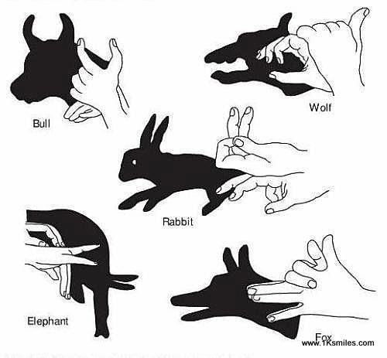
Art and Design
I would like you to be creative with light and shadows. Find a light source, it can be the sun, and a surface where you can see shadows clearly. Can you create a shadow that looks like an animal using your hands or things you find in your house or garden? Take a photograph or draw a picture to show what you did.

Physical Education
Remember to be active every day; it will help you keep your mind and body healthy. Have you tried any balancing games? Where on your body can you balance a ball and for how long? Can you improve over the week? We are still doing the Joe Wick’s workout every day in school, have you?

Please feel free to share any of your hard work and creations with us in school; we’d love to know how you’re getting on. Send pictures or files to us using secretary@st-neot.cornwall.sch.uk

