St. Neot Primary School
A Parent Guide to Google Classroom
We are using Google Classroom for all children for our remote learning offer.
Google Classroom is a space where your child can access their learning online. It is available through a laptop or Chromebook as well as a downloadable app on most tablets and smartphones, you can even access it though the Xbox and PlayStation consoles.
Below are instructions for how you and your child can log on and access their remote learning.

Username and Password
Each child has a unique username and password to log on. Their username is made up of their first name, a full stop, their surname and then the school email domain. For example, a child called Jane Smith, their username would be: jane.smith@st-neot.cornwall.sch.uk

Your child will also have a password. You will have received an email containing your child’s username and password. Please keep this information safe.

If you need help with this, please contact your child’s teacher.

Accessing Google Classroom
There are many ways to access Google Classroom.

If you are using a Desktop PC, Mac or laptop, this can be done by clicking on this link https://classroom.google.com or typing it into the search bar on your browser.

If you are using a Chromebook, you will need to download the Google Classroom app from the Web Store. Once done, you or your child can sign in using their school login. If you are unable to do this, it may be that you will need to login to the Chromebook using your child’s username and password instead from the start-up screen.

If you are using an iPad or other tablet or smartphone, please download the free Google Classroom app from the App Store.

If you are using Xbox One & Xbox Series X/S, please follow the step below:
1. Plug a wired keyboard into your Xbox One, Xbox Series X or Xbox Series S via one of the USB ports on the front or back.
2. Press the Xbox button top-centre of a game controller and head to "My games & apps" in the side menu.
3. Click on "See all", scroll down to "Apps" and you will see Microsoft Edge in the icons on the right-hand side. Open it.
4. Type classroom.google.com into the URL bar at the top and log in as you would on a PC using your username and password.
5. You can either use an Xbox controller to move the cursor or a separate USB mouse plugged into one of the other ports.

If you are using PS4 & PS5, please follow the steps below:
1. Plug a wired keyboard and/or mouse into the USB ports on the PS4 or PS5 - each console should recognise them.
2. Identify the PlayStation internet browser (it is the WWW icon with dots around it) in the URL bar of the browser, type classroom.google.com and then log in using your username and password.

When you arrive at https://classroom.google.com/ you will see the screen pictured below:

To sign in you or your child should enter their username as detailed above. This needs to be the full username, for example, jane.smith@st-neot.cornwall.sch.uk
Click next.

On the first login, some boxes will appear. Please click ‘Accept’ on the first box.
Please click ‘Continue’ on the second box.
Please click ‘I’m a student’ on the third box.
Now enter their password, which is case sensitive.
Click next.

Click on the name of their school classroom to enter their Google Classroom.
Your child’s class area will look like this (with their own class name displayed).
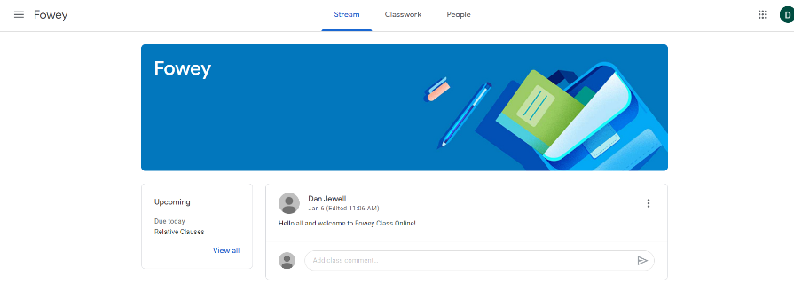

Navigating Google Classroom
From the main class screen, you and your child will be able to navigate to the different parts of their classroom. Across the top of the page you will see the following areas:

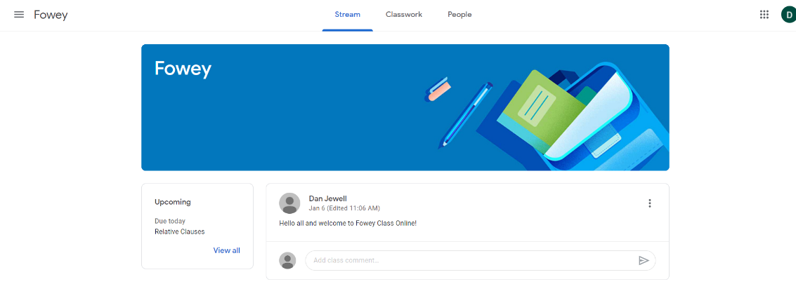

Stream
This is where your child will see posts from their teachers. Posts may contain links to websites, classwork set by your child’s teacher or simple communications between all the members of the class.

Posts are always monitored by your child’s teacher, as are any accompanying comments made by individuals, so we ask that children only use this feature if they are asking a question about their work or responding sensibly to a post.

Classwork
This is where you and your child will access their remote learning assignments set by the teacher. This is the best way of accessing the content set rather than having to worry about searching on the Stream. Any assignments added will be in the form of a Google Doc, Google Slide or other Google Suite app (If you are using a tablet, you may be required to download additional free apps) as this will allow the children to edit and hand in their work individually to the teacher.

Classwork will be added regularly and may have a due date for completion. Teachers will be able
to see your child’s progress and support them where necessary and can add comments to the children’s work. Under the Classwork tab you will see days for the week. Under this you will see the remote learning assignments for each day. On a daily, or weekly basis, these days will be populated with remote learning assignments for your child. Routines are important to children and we will post a suggested timetable for each week in the Google Classroom.

If your child is stuck with a piece of work, they can post a comment using the private message function at the right hand side of the screen to message the teacher. Please note that teachers are working in school with groups of children during the week so won’t be able to respond to
messages straight away.

People
This area shows which teachers and pupils are assigned to the same classroom.

Assignments – ‘How to’ Guide
Assignments are the remote learning tasks set by your child’s teacher. They are found in the Classwork area of Google Classroom. Please follow the example below as a guide to opening, completing and submitting an assignment.

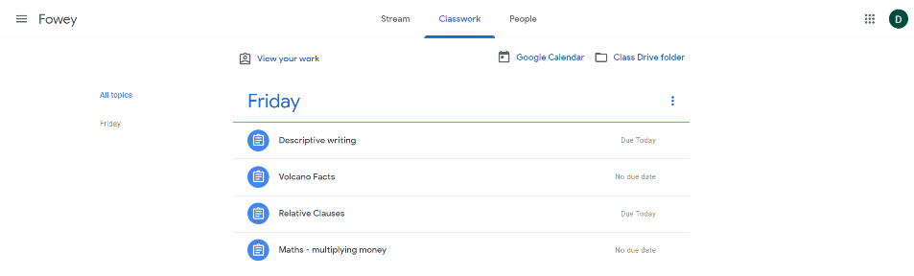
Under the day’s heading you will find the group of assignments for that day.

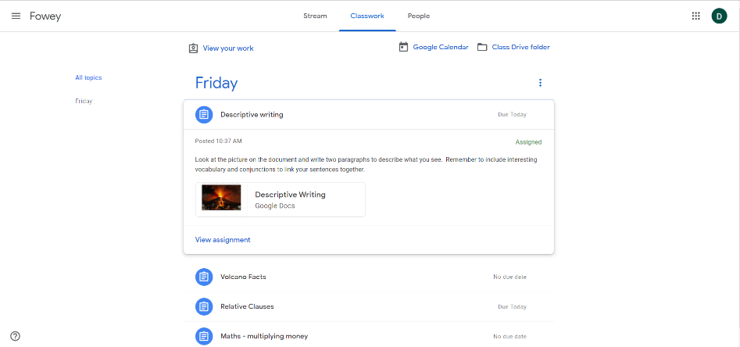
By clicking on an assignment it will expand and provide more information and any files.
You can then click ‘View assignment’.

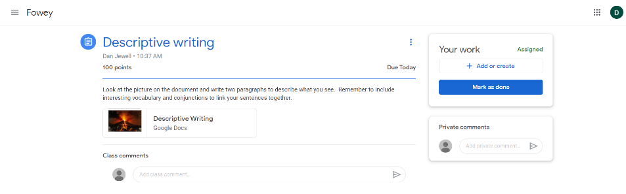
Click on files to open them.
Type and post private comments for the teacher here.

This is where you or your child could ask their teacher questions about that assignment.
You can open any attached files and undertake the activities. All files save automatically to your child’s Google Drive, so you don’t need to worry about saving or losing work.

When an assignment is complete, click ‘Mark as done’ to submit it to the teacher.

The teacher can then look at the submitted work and provide feedback.

You can also find a parent’s guide video to Google Classroom, where more of the Google apps are introduced, at: https://www.youtube.com/watch?v=2Iowi-gmbys

