Fowey Class Home Learning Activities – Tasks 4

Hi everyone! We’ve had such lovely weather; I hope you have been enjoying it. Keep up the regular exercise and healthy eating. Be good and stay safe.

Year 6 Revision Book
Reading – pages 50/51 (poetry)
Maths – page 16 and pages 36/37
SPAG – page 7, pages 44/45 and pages 78/79

Year 5 and 6 Project
This week’s project is food and drink. You will need to use many skills, including investigation, writing and measuring. You will be exploring nutritional values and the amount of sugar in different foods and drinks. As usual, you can create a presentation (written, display or PowerPoint) to show what you have done.

Reading
Reading helps to keep the mind healthy and the imagination growing. You need to continue reading plenty of texts and genres. Remember to ask an adult for help if you are unsure what something means.

Spelling
Good work, Fowey. Last week 15 children accessed Spelling Shed. Please check regularly for new assignments.

Writing
- Linking to your science task, create a poster or display advertising your new packed lunch product. Your advert should use exaggeration and persuasive techniques to encourage people to buy it.
- Choose one of you short stories from last week; write a detailed opening to the story, which describe the setting and aspects of a character’s appearance in detail.
- Write a poem or jingle about you healthy packed lunch.

Maths
- Use your number spinner to create division questions. Create a 2- or 3-digit number and divide it by a 1-digit number using the bus shelter method. When you have a remainder, Y5 show it as a fraction, Y6 as a decimal to 2 decimal places. Repeat this several times until you are confident.
- Create a bar chart showing the amount of sugar in different foods or drinks. Look at the nutritional information on the packaging. Don’t forget to label the x and y axes.
- Create a mathematical diary of a day. Write down the time you do an activity in analogue and digital time. When you have finished, calculate the intervals of time between the activities.
- Please don’t forget TTRockstars, last week only eleven people from Fowey class logged on.

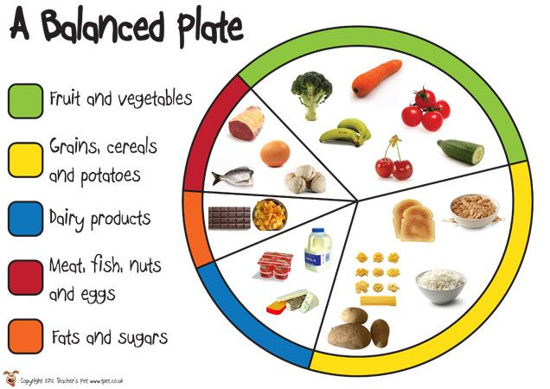
Science
You need to design a healthy packed lunch that supermarkets could sell. It will need to be a balanced meal (see picture). You need to include a main element, some fruit / veg, a dessert and a drink. Try to be imaginative with your design, think about sustainability and keeping the food fresh. Can you include all the food groups in you healthy packed lunch?

Art and Design
I would like you to design packaging for your healthy packed lunch. You need to include the name of the product, a slogan, pictures and nutritional information. Can you look at other packaging for ideas and inspiration? You could include other features you see, like a barcode too. If possible, create the packaging with card.

Physical Education
Don’t forget to be active and outdoors. Have you tried throwing and scoring games? Make a simple goal or hoop and try to score by throwing objects into / through your goal. How many can you get in one minute? I’m still doing the Joe Wick’s workout every day and Jack still laughs at me every time.

I’ve seen some excellent work so far. Please do share what you are doing by sending pictures or files to us using secretary@st-neot.cornwall.sch.uk

