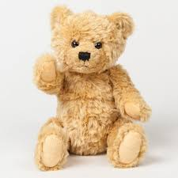
Teddy Bears Picnic

Literacy
Write invitations to your teddy bears so they can join you in a picnic.

Learn a new story to recite to the teddys at the picnic or take a book with you to read to them.

Maths
Count how many teddy bears are going, how many plates and cups will you need?

What shapes are cups, plates, and books you may need for the picnic.

Will you need a big bag or small bag to carry all your picnic items and your teddy bears? Is the bag heavy or light?
Would it be easier to separate the items into more than one bag?

Physical Development
What is the weather like, what are you going to need to wear? Can you put on some of your own clothing, hat or shoes?

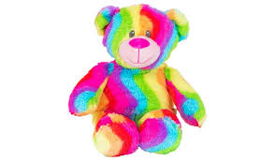
Holding the pencil between your thumb and two fingers can you make anticlockwise circles and turn them into smiley faces.

See if you can help peg out some washing (With adult support).

Communication & Language
With parental support plan what you would like for your picnic, do you need a check list?

Maybe you could suggest some ideas for different types of sandwich fillings etc…

After your picnic you could recite a few nursery rhymes: Hey Diddle Diddle, Humpty Dumpty, Grand Old Duke of York.

Personal, Social & Emotional Development
Invite family members to join you on the picnic, ask what they would like to eat.

Make sandwiches for your picnic with adult support, and organise other food, fruit and drink.

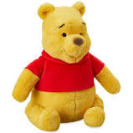
Remember sharing is caring at the picnic.

Expressive Art & Design
Can you draw a picture of your favourite teddy bear or cuddly toys?

Explore sounds by banging pots and pans with a wooden spoon or spatula (You may even be able to stay up and do this at 8pm on Thursday evening in support of the NHS and Key Workers).

Puppet Play - can you make puppets from a pair of socks, give them eyes and a voice.

Understanding the world
Where would be a nice place for a picnic in the garden or other outside space? You could always have a picnic inside.

Thinking about our picnic where do you think the food/ingredients come from, butter, bread, fruit etc…

Can you name any famous bears from books or films? (Paddington, Winnie the Pooh, Rupert Bear, Yogi, Baloo, Little Bear.)

