Home Learning Tasks
People that Help Us / Real Life Heroes
English
1. Make a list of people in our lives that help us. Think about friends and family and then think about people in the wider community. Who are these people? How do they help us? Can you think of adjectives to describe these people? Ask an adult to help you think of interesting, more challenging words and explain their meaning. For example, nurses need to be compassionate. What does that mean? Can you use the word in another sentence? Make a list of your amazing adjectives and send them to us!

2. Create a “thank you” card for someone in the local community that has helped you (or others) over the last couple of months. You could explain why you are thankful and tell them what a great job they have been doing. Illustrate the card with carefully drawn pictures and ask an adult to post it.

3. Last week (on Tuesday 12th May) we celebrated International Nurses Day. This date marked the 200th anniversary of Florence Nightingale’s birth. Who is Florence Nightingale? What did she do to help people? Why is she so important? Create a fact sheet about her life and the impact that she had on the nursing world.

4. Write a letter to one of your friends or the teachers at school. Explain what you have been doing at home and be sure to include anything funny or interesting that has happened to you. Is there anything that you’re proud of? What are you missing about school? What do you want to do first when things return to normal? Ask the recipient of your letter some questions about their time at home. Ask an adult to help write your letter in the correct format with your address in the top right and the correct opening/closing statements.

5. Continue to practise spellings on Spelling Shed. These will be updated weekly and will contain new spellings and some from previous weeks. If you would like extra spelling practice, look at the Common Exception Words on the following page, making sure to choose the correct list for your year group. Practise spelling these words as much as possible, using different strategies to help remember any unusual spellings.

Maths
1. Look at the coin values on the following page. Make sure you know the values of the different coins. What is the smallest value coin? What is the largest value coin? Ask an adult to give you a value between 10p and 50p. How could you make this exact value with coins? Is there another way that you could make it? How many different ways could you find? If you would like a challenge, can you solve the money problem on the following page?

2. Practise recalling number bonds to 20. You should be able to recall the pairs of numbers that add to make 20 quickly and confidently. Ask an adult to shout out a number below 20. In response, shout out the number which goes with it to make 20!

3. Write down all of the number facts up to 20. For example: 1 + 19 = 20. Encourage children to recognise and write down all of the associated number facts, including the inverse calculation.
If I know that 1 + 19 = 20, then I should know that 19 + 1 = 20.
I should also know that 20 – 19 = 1 and 20 – 1 = 19.
Write the number sentences as “fact families”.
1 + 19 = 20
19 + 1 = 20
20 – 1 = 19
20 – 19 = 1
If you need more of a challenge, ask an adult to give you an initial number sentence. Can you work out the associated number sentences, including the inverse? For example: 79 + 21 = 100…

4. Continue to practise telling the time to the nearest quarter of an hour on an analogue clock (extending to the nearest 5 minutes). As an extension, encourage children to understand the relationship between telling the time on analogue and digital clocks.

5. Practise your number facts using Hit the Button (a free maths game which helps to improve recall of number facts). Search Hit the Button for free on Google. Focus on number bonds to 10 and 20, doubling and halving and times tables. How many questions can you get right in 1 minute? Record your best scores!
6. Continue to practise your recall of multiplication and division facts using Times Table Rock Stars!

Topic
1. Ask an adult to explain what to do in the case of an emergency. What should you do if you need the police, ambulance, fire service or coastguard? Try your hardest to remember your address and postcode, just in case you ever need to pass it on to an emergency service. However, remember that you should never give out your name or personal details to someone that you don’t know (other than emergency services).
2. Look at the most recent piece of art by the street artist known as Banksy on the following page. What does the picture show? What do you think the artist is trying to say through this image? Can you create your own Banksy-inspired piece of artwork to show your appreciation for those people that help us?
3. Florence Nightingale was known for highlighting the importance of personal hygiene when caring for people in hospital. She emphasised the importance of regular handwashing to stop the spread of germs. This is a very important message; particularly at the present time. Create your own poster to highlight the importance of handwashing.
4. Create your own superhero! Draw a picture of your superhero and give them a name. What words would you use to describe them? What are their super powers? How would they help the world or other people? Write a couple of sentences to describe your superhero.

Other Activities
1. Watch BBC Newsround and find out what is happening in the world. What did you find out? Is there anything you need help understanding?
2. Practise writing your full name correctly, including any middle names. Remember to use a capital letter at the start of each name and ask an adult to check whether you have spelt it all correctly. Once you are confident at spelling your names correctly, play the quick write game. How many times can you write your full name (neatly and correctly) in two minutes?
3. Read as much as possible. Call a family member or a friend and read a book to them on the phone. Remember to use expression and pause for full stops! There are lots of books available to read online. For example, on the Oxford Owl website or as PDFs.
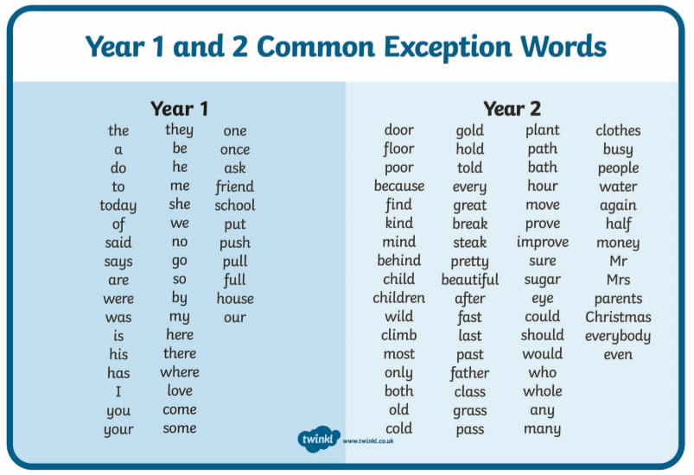
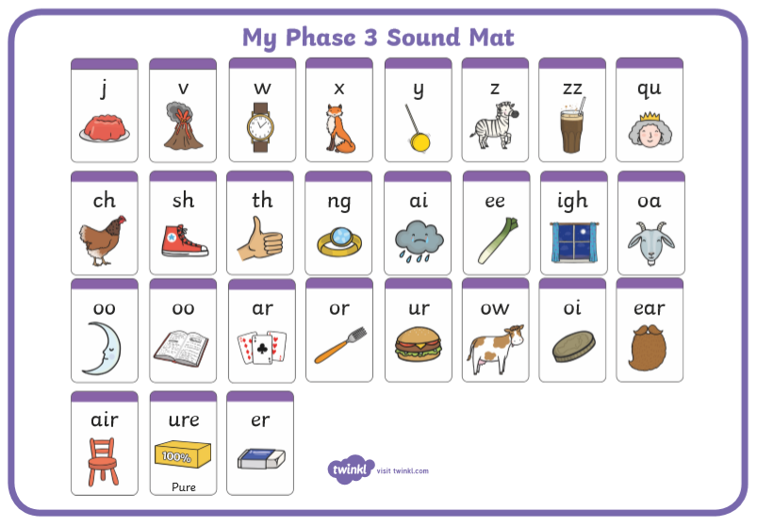
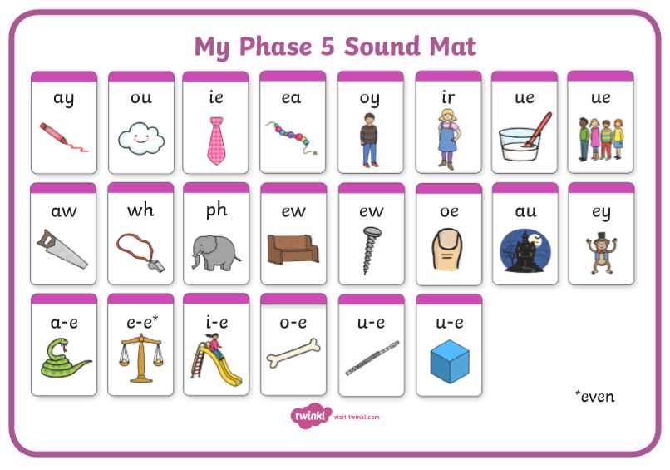
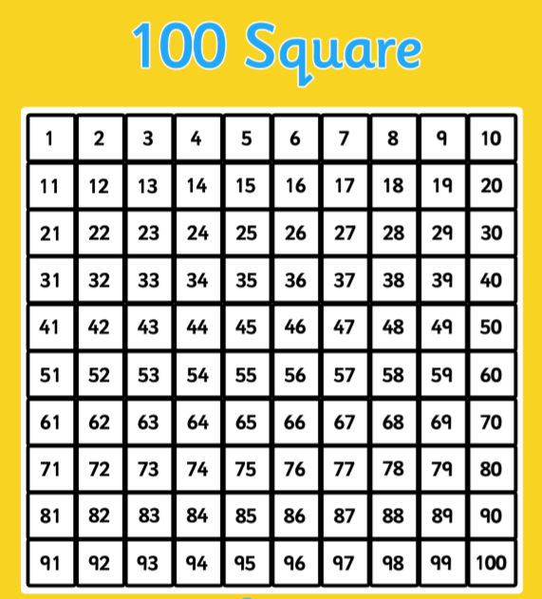
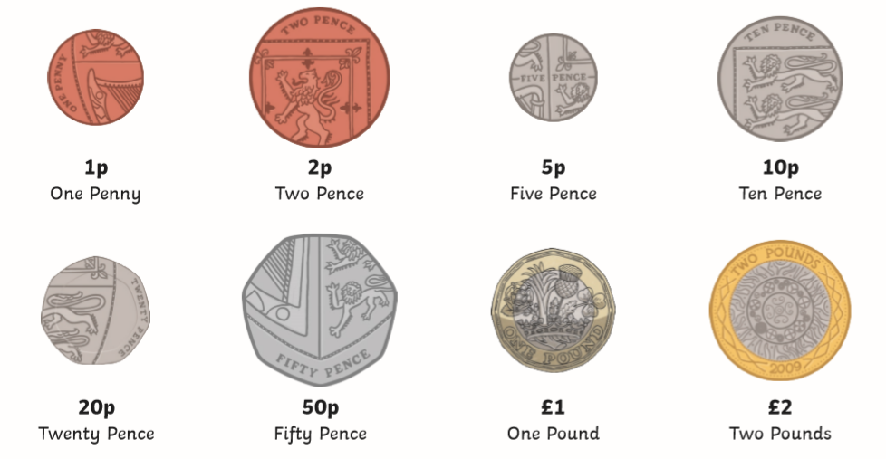

Money Problem Solving Challenge
