TREVERBYN HOME LEARNING ACTIVITIES 13
Hello everyone. This week we have been very poetic at school. We have also focussed on time and graphs. A few volcanic explosions and tsunamis occurred but luckily only in our poems. I hope you are continuing to read, exercise and eat healthily.
ENGLISH
POETRY
Haiku
We have being learning about different types of poetry. We have concentrated on Japanese forms of poetry, the Haiku and the Tanka. These are both forms of poetry where the number of syllables in each line is important. The Haiku is normally about nature and has three lines. The first line has 5 syllables, the second has 7 syllables and the third line has 5 syllables again. I would like you to have a go at writing about a volcano using the Haiku form of poetry. Here is an example:
Rising to the sky
Snow capped sleeping mountain wakes,
Lava creeps slowly.
Tanka
The Tanka is similar to a Haiku as it is also about nature. It has five lines. The first line has 5 syllables, the second has 7 syllables and the third line has 5 syllables again just like a Haiku. The final two lines each have 7 syllables. This time I would like you to have a go at writing about a Tsunami using the Tanka form of poetry.
Tectonic plates shift,
The Earth’s crust cracks wide open.
Water rushes in.
A wave heads towards the shore
Growing larger, danger looms.

STORY
I would like you to write a story where you are involved in a natural disaster. It could be an earthquake, a tsunami or a volcanic explosion. I just hope you survive!

SPELLING SHED
This is updated every week. Year 3 have challenge words and Year 4 you have some tricky words with plural apostrophes.

READING
Read daily for at least 15 minutes. Don’t forget you can still join the Library Summer Reading Challenge. Details are on the school website under the Home Learning tab.

MATHS
TIME
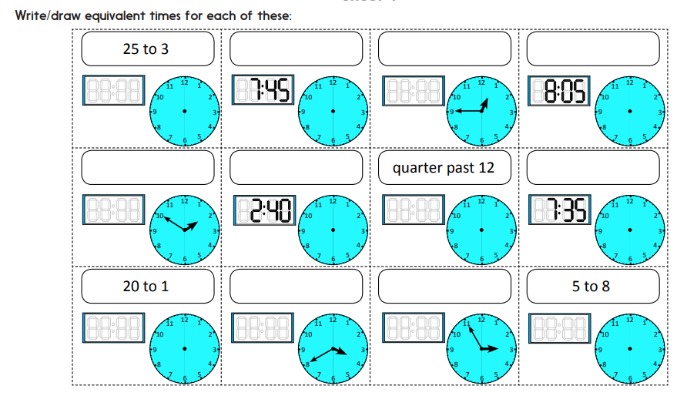
Practise converting between written time, analogue time and digital time.

See if you can convert the following times to 24 hour clock. If the time is pm add 12 to the hour. For example 1.15 pm would be 13.15. You do not need to use am or pm in the 24 hour clock.
Show these 12-hour digital clock times on an analogue clock face. Then convert them to 24-hour digital times.
- 2:35 pm 2. 4:55 pm 3. 1:20 pm 4. 1.10 am 5. 8:45 am 6. 9:05 am 7. 10:15 am 8. 2:50 pm 9. 10:40 pm 10. 4:30 am

BAR CHART
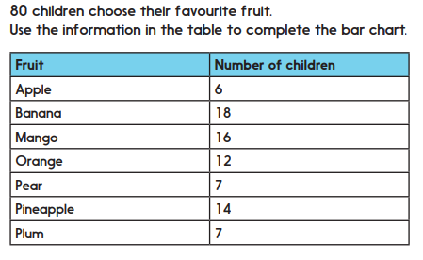
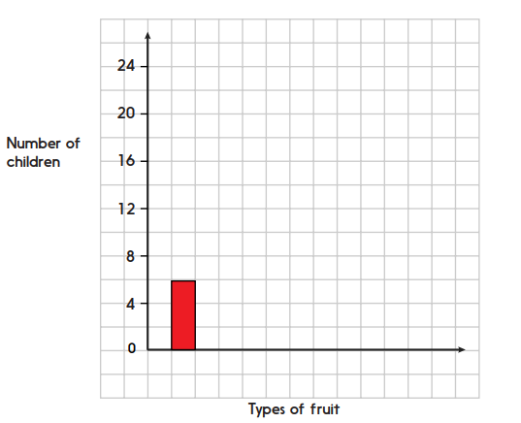

LINE GRAPHS
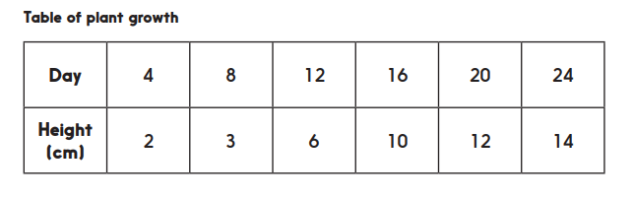
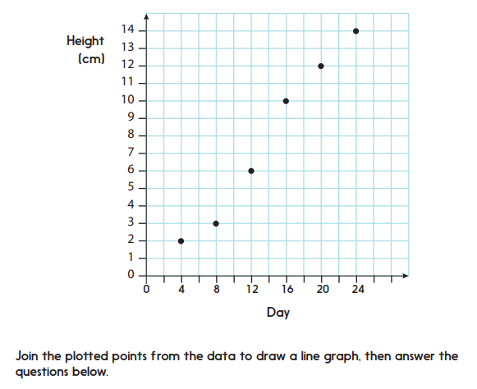
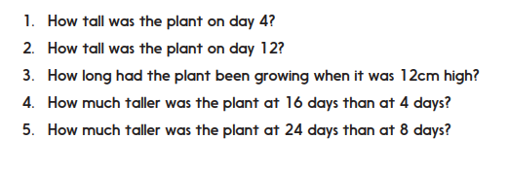

TT Rockstars.
Try to go on this at least three times during the week.

SCIENCE
This week we have finished our investigation into soils. If you can, get two or three different samples of soil and conduct the following investigation. Write up your experiment including a list of equipment, a method and a labelled diagram.
Soils can also be different in ways you can’t see, for example when it rains, some soils absorb lots of water (let’s call these soakers) but others allow the water to drip right through them very quickly (we will call these drainers). Do a scientific test to find out which of our soils is the best soaker (the one that absorbs the most water), which is the best drainer (the one that let’s through the most water) and which one is in the middle. Make a prediction – Guess which soil will be the best soaker

Method
1. Put a cotton wool plug inside a funnel
2. Stand the funnel inside a container
3. This is your soil test equipment. You will need to make one for each type of soil
4. Your soil will go in the funnel and you will be able to pour water over it to see how much drains through into the container
5. Measure the exact amount of water (in ml) that drains through by pouring it into a measuring cylinder or jug.
Think about how you will make it a fair test. What will you keep the same and what will you change?
Draw a labelled diagram and a results table.

