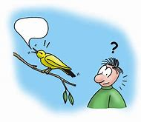
Sounds

Literacy

Retell or act out a favourite story from memory with support from a family member.

Try and form the letters of your name in one colour, then trace over the letters in another colour, with adult support

Maths

Can you make a pattern out of Duplo/Lego bricks, repeating two colours?

At home count household objects that make loud noises, then objects that make quiet noises

Are there more loud objects or quiet objects?

Physical Development

Moving like an animal can you: slither like a snake, hop like a frog, creep on all fours like a tiger, gallop round the garden like a horse?

Try and brush your own teeth in the morning and last thing at night before bed with support

Play a chasing game outside with a family member, try your hardest not to get caught!!

Communication & Language

Read a book with noises in it e.g. farm animals, emergency services & transport.

Little helper following instructions, e.g. water the plants, hoovering, feeding the cat/dog

Support understanding of what’s happening and why: not being able to see extended family members or go to Nursery

Personal, Social & Emotional Development
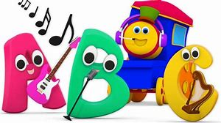
Home baking, make cupcakes or biscuits for the whole family

Turn the radio up and have a sing song with family members

Play Hide ‘n’ Seek around the home remember to be quiet as possible!!

Expressive Art & Design

Be treated like princess, unicorn, super hero or dinosaur for a day, dressing up and pretend

Explore sounds of different instruments either in the home or online with adult support

Make your own instrument (Shaker) use a small empty bottle or container and rice

Understanding the world

Go on an environmental listening walk what sort of noises can you hear? What’s making the noises?

What sort of voice do we use in a shop? Quiet or loud? What about in school, cinema, pantomime, in a swimming pool etc…?

