TREVERBYN HOME LEARNING ACTIVITIES 6
Hello everyone. Here we are at the end of another week. I hope you are all well and enjoying the extra time you are spending with your family. It would still be good for more of you to go on TT Rockstars and Spelling Shed, I’m keeping track so I can award house points when we get back to school.
ENGLISH
As we celebrate the anniversary of VE day on Friday, it seems a fitting time to think about heroes. I would like you to write about someone you consider to be a hero. It can be an inventor, sportsman, a family member or rock star. Remember to write about where and when they were born, their life, and why you consider them a hero.
STORY
Write a story in the form of a comic strip about something heroic. Maybe the main character saves someone’s life or stands up for something they believe in. They could score a winning goal or raise money for charity. Make it bright and colourful.
COMPREHENSION
BEDTIME STORY

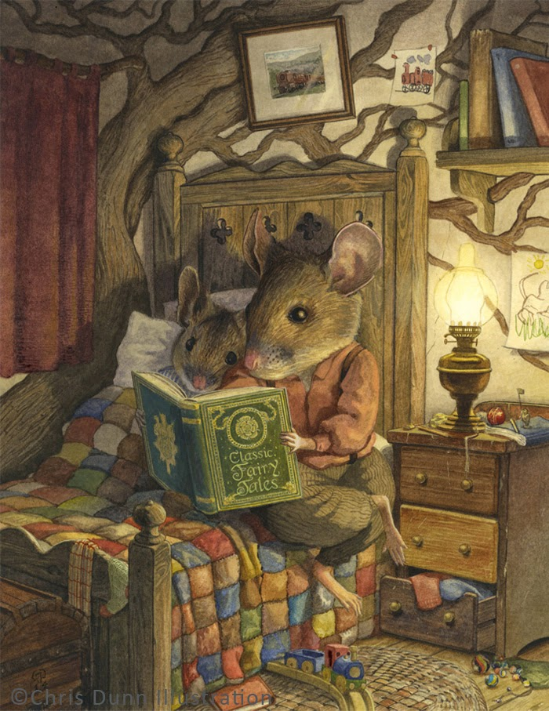
Credit: Chris Dunn

- Whose bedroom is this?
- What can you tell about his personality and interests?
- How old do you think the boy mouse is? Why?
- Which fairy tale do you think they might be reading?
- How long do you think they have been reading for?
- Do they read every night before bed?

SPELLING SHED
This will be updated regularly.

READING
Challenge yourself to read every day for at least 15 minutes. Complete a book review.

MATHS
SCALING UP
You are holding a street party and expecting 25 guests. How much of each item would you need if the party was twice as big? What if it was four times as big? You don’t need to print out the table you can copy it.
 | Standard Party (25 guests.) | Party 2 X the guests | Party 4 X the guests
Cups | 35
Large Jugs | 5
Serving plates | 13
Side plates | 40
Sandwiches | 75
Sausage rolls | 50
Mini quiches | 45
Jelly | 6
Ice cream Tubs | 4
Cupcakes | 25

COMBINATIONS
You have three flavours of ice cream. Chocolate, Strawberry and Vanilla and three toppings, Sprinkles, Flake and Caramel Sauce. Each flavour ice cream can be served with one topping. Calculate how many possible combinations there are. Try to be systematic to make sure you have all combinations. You could copy and continue this table.
Ice cream | Topping
Chocolate ice cream | Sprinkles
Chocolate ice cream | Flake

Challenge
What if there were four choices of ice cream flavour, and the same three toppings? What if there were four choices of ice cream and four toppings?

ADDITION AND SUBTRACTION
Keep on practising column addition and subtraction.

TT Rock Stars. Please go on TT Rockstars.

SCIENCE
This week I would like you to investigate whether the temperature of water affects how quickly substances dissolve. Try cold water, warm water and hot water. Make your predictions first and then conduct an experiment. Try to be fair, accurate and consistent. You could use sugar, salt, coffee granules or anything else you think will work. Record your results in a table.

HISTORY
Draw a family tree. If you can record dates of birth. How far back can you go? My eldest son is called George because there has been a George Bennett in every generation of my husband’s family since 1704. Are there any recurring names in your family?

ART
Draw the view from a window in your house.

PE
Keep active. Try Joe Wicks, Cosmic Yoga, ride, run, bounce, dance. Aim for at least 30 minutes of activity every day.

