TREVERBYN HOME LEARNING ACTIVITIES 3
ENGLISH
POETRY
Write a poem in the style of your choice about the weather.
ALLITERATIVE SENTENCES.
Find objects around the house and create alliterative sentences. An example would be: Boring brown boxes become beautiful buildings. What is the longest sentence you made?
SPELLING SHED.
This will be updated regularly. Only 11 people went on spelling shed this week. Let’s try to get everyone on it this week.
EXPLANATION TEXT
Design a robot for a specific task that you do not enjoy. An example would be a robot to clean your room. Explain why you would want the robot to do this task? Draw a detailed and labelled picture of your robot.
READING
Read a newspaper or magazine article. Write down three facts you learned. What else would you like to know?
Keep on reading.
MATHS
Measure the perimeter of each room in the house. Remember perimeter is around the edge. Can you convert the measurements into metres, centimetres and millimetres?
Roll two dice to make a fraction. Put the smaller number as the numerator and the larger number as the denominator. Eg. 3/6. Now make equivalent fractions by multiplying both numbers by the same amount. 3 X 4 = 12. 6 X 4 = 24. Therefore 3/6 is equivalent to 12/24. Year 3’s can use 2, 3, 4, 5, and 6 x table to make six equivalent fractions while Year 4’s could try to create at least 12 for each fraction. How many can you make?
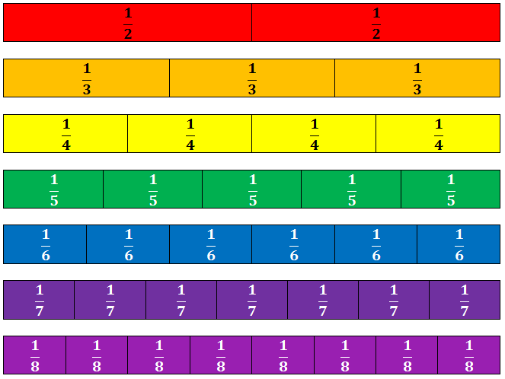
Investigate how many different jumpers can be designed if each sleeve, the front and back are different colours. You are only allowed 4 colours.
See if you can beat your record on TT Rockstars. Only 11 people went on the program last week. Let’s see how many can go on it this week.
DESIGN TECHNOLOGY
Create a robot using empty boxes and bottles.
SCIENCE
Spend half an hour in the garden or looking through the window. Keep a record of how many, and what type of birds visit. Turn this information into a Tally chart. Can you create a block graph from this information? Try at a different time of day. Did it make a difference to your tally?

PE
We are doing the Joe Wicks workout at school, why not try it if you haven’t already.

