Weather
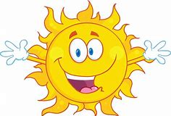

Literacy

Watch ‘What will the Weather be like Today?’ by Paul Rogers https://www.youtube.com/watch?v=BgvbpxTX0rM
Listen to the book together, turn off the sound and reread book. Child to repeat ‘What will the weather be like today?’ Discuss different weathers and which clothes would be worn.

Create a weather picture, it may be raining, snowing or very cloudy, it could have a rainbow

Make a weather chart
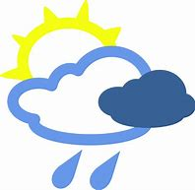
Maths

Measuring rain (put a measuring jug in the garden and see how much rain falls)

Count how many clouds you can see in the sky.

Are the clouds big or small clouds? Do the clouds look like anything?

Physical Development

Try sitting on the potty or toilet, always wash your hands afterwards (see government guidance, you should wash your hands for 20 seconds, using soap and water) Sing ‘Happy Birthday twice whilst washing hands.

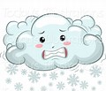
See if you can balance on one leg. Then hop.

Jumping in puddles/paddling pools (don’t slip!) or log rolls on the lawn.

Communication & Language

Is rain warm or cold? What about snow, ice, wind, and sunshine?

Recite weather rhymes (I hear thunder, It’s raining its pouring, Incy Wincey Spider, The sun has got his hat on)

Personal, Social & Emotional Development

Go for a short walk with a family member, is it sunny or cloudy, is the wind blowing, what is happening to the trees?

What clothing should you wear on your walk?
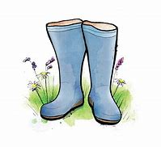
What’s everyone’s favourite time of year, spring, summer, autumn or winter

Expressive Art & Design

Explore different textures: ice (cubes) when frozen and melted, wind (hairdryer) etc…

What colours are rainbows, snowflakes etc. What about thunderclouds?

Make a rainbow picture to display in a window to support the NHS and other key workers (don’t forget to clap at 8pm on Thursday to support Key Workers or even bang a saucepan)

Understanding the world

What types of weather do we need to make flowers and trees grow?

Make a weather diary or put each day’s weather on a calendar (draw a sun or cloud depending on weather)

How do we know what the weather forecast will be tomorrow where do we find it?

Don’t forget sun cream and a hat if it is hot. An umbrella and wellies if it rains.

