TREVERBYN HOME LEARNING ACTIVITIES 8
Hello everyone. I hope you are all well. Lots of you are probably riding your bikes more at the moment. I hope you are remembering to wear a helmet. It would be really good to hear from you. Stay safe.
ENGLISH
LETTER WRITING
We would love you to write to us and tell us what you have been doing during lockdown. Have you been able to achieve something while stuck at home such as mastering recipes, riding a bike, learning to use SKYPE or Zoom? Who or what have you missed the most?
Remember to begin your letter with a salutation, give a reason for why you are writing the letter, then write about what you have been doing. It would be good if you could write about the negative aspects such as missing friends and family as well as all the exciting things you have been doing. Any letters received at school will go on a display for your friends to read.

COMPREHENSION

BEDTIME STORY

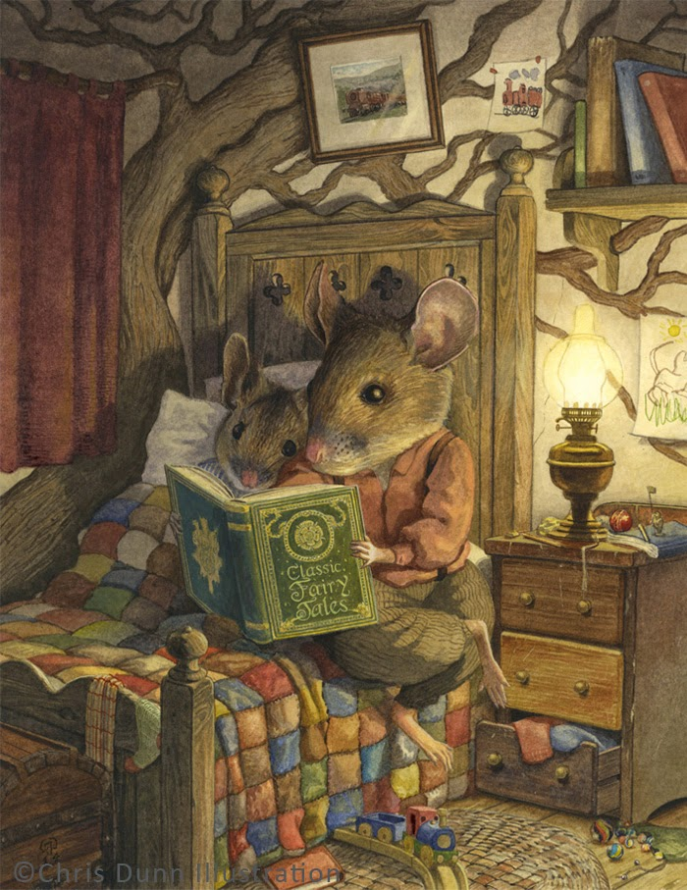

- Whose bedroom is this?
- What can you tell about his personality and interests?
- How old do you think the boy mouse is? Why?
- Which fairy tale do you think they might be reading?
- How long do you think they have been reading for?
- Do they read every night before bed?

Please use the words in the question to help you answer the questions.
SPELLING SHED
This is updated every week. Year 3 have ‘gue’ and ‘que’ spellings this week. See if you can find out what the definition of each word is and then write it in a sentence. Year 4’s can you do the same with your ‘sol’ and ‘real’ word family words.
READING
Read daily. The library are launching their Summer Reading Challenge on line. This year’s theme is Silly Squad, a team of animal friends who love to go on adventures and get stuck in to all different kinds of funny books. For 2020 it’s all about funny books, happiness and having a laugh!

The Summer Reading Challenge combines FREE access to books with fun creative online activities. This year it has been extended and will be launched on Friday 5th June and run until mid-September. You can find out more and sign up by going to https://summerreadingchallenge.org.uk/. Let’s make Tracee happy by signing up and show her we are thinking about her.

MATHS
TIMES TABLES
3 and 4 times table investigation.
1. Take a two-digit multiple of 3. Reverse the digits. Write the new number.
2. If it is not immediately obvious, test to see if it is a multiple of 3, by dividing by 3 and seeing if you get no remainder, e.g. 24, reversed is 42. ? x 3 = 42 10 x 3 = 30 leaving 12 4 x 3 = 12 no remainder
3. Repeat this a couple of times.
4. Are all numbers in the 3x table also multiples of 3 when reversed?
5. Now try the same thing with multiples of 4. For example: 16 reversed is 61 ? x 4 = 61 10 x 4 = 40 leaving 21 5 x 4 = 20 remainder 1
Can you work out which numbers in the 4x table are still multiples of 4 when their digits are reversed. Can you explain or demonstrate how you can tell if the number will be a multiple of 4 when the digits are reversed?
18 times table - wow!
1. Use the grid method to work out 3 × 18.
X | 10 | 8
3 | 30 | 24
30+24=54
2. Add the digits together in the answer. 5+4=9
3. Now work out the 18 times table from 1 × 18 to 10 × 18 or even beyond!
4. Each time add the digits of the answers together. What happens? Look at the pattern in your answers in order. What happens to the 10s digits? And the 1s digits? Does this help you to realise why the digit sums are as they are? Use a calculator to multiply any number you like by 18, then add the digits together. Does the same thing happen? If you get an answer with two digits, add them again until you get a one-digit answer, e.g. 27 × 18 = 486. 4 + 8 + 6 = 18, 1 + 8 = 9.

TT Rockstars.
Try to go on this at least three times during the week.

SCIENCE
As we are thinking about rocks at school I thought you might like to find out about them too. Can you research the three different types of rocks? Write about each type of rock explaining how it is formed and where it can be found. Bodmin Moor is mostly granite. What type of rock is this?

PSHE
While you are at home it would be good for you to learn some life skills. This week it would be good if you could help around the house. Try making your bed, changing the sheets, finding out how to use the washing machine. Can you make breakfast or lunch for your family including laying the table and washing up afterwards?

PE
Keep active, it’s good for your health. Try dancing, cosmic yoga, the Joe Wicks workout, cycling or going on a walk.

