TREVERBYN HOME LEARNING ACTIVITIES 5
Hello everyone. I hope you and your families are well. The weather has been fantastic so I hope you have all been out in the garden enjoying the sunshine. Thank you to those of you who have sent some of your work to Dee. It’s great to see how hard you have been working. It would be good for more of you to go on TT Rockstars and Spelling Shed, I’m keeping track so I can award house points when we get back to school.
ENGLISH
EXPLANATION TEXT
Write an explanation text about how to look after a pet of your choice. It can be a pet you have or one you would like. Remember to write about what they need, what they eat, what they will need to play with.
STORY
Write a story about the pet above being lost. How did they get lost? How did you find them? Do not forget to use exciting vocabulary, good description and a good structure. If you use direct speech, use inverted commas and a new line for each speaker.
COMPREHENSION
SOMETHING FAMILIAR
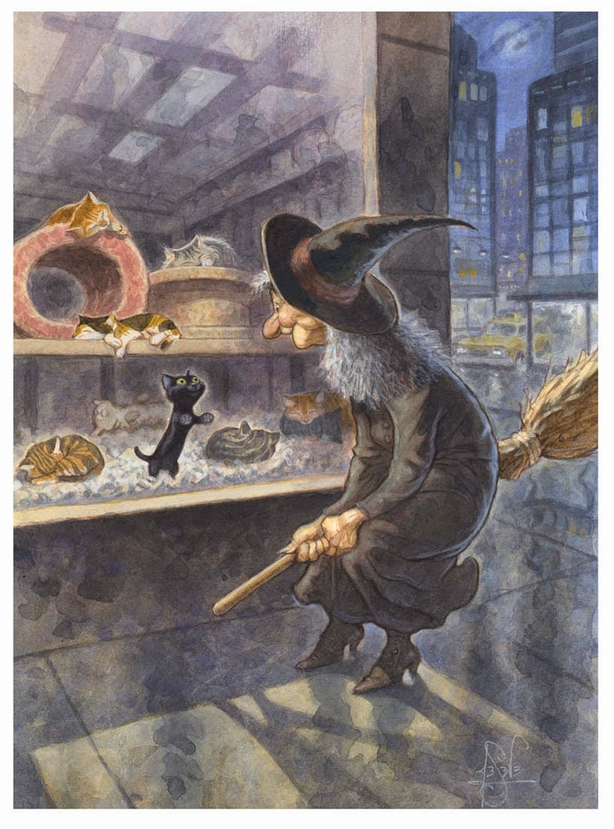

Credit: Peter de Sève
- Why is the black cat the only cat looking at the witch?
- Why did the witch come here? Was she just passing or did she come to the shop for a reason?
- What is the ‘something familiar’? Why?
- Do the witch and the cat already know each other?
Answer the questions as fully as possible using the words in the question to help.
SPELLING SHED
This will be updated regularly.
READING
Read as much as possible this week. Try to read something different that you would not normally choose.

MATHS
MONEY- MAKING CHANGE
1. Draw three boxes in a vertical column.
2. Write an amount greater than £5 in the top box on the diagram.
£10.00 | £5.63
£ 5.00 | £4.37
 | £0.63
3. Find the change from £10. Amount Change
4. Write the answer in the second box.
5. Find the change from £5.
6. Write the answer in the third box.
7. Compare the pence in the numbers on the top and third step.
8. Repeat this five times with different starting amounts.
Have you tried amounts with no 10ps? For example £6.07. How about amounts with no 1ps? For example £6.70. Why does this work? Can you write an explanation?
CHALLENGE: Try this with four steps – Change from £20, then change from £10, then change from £5… What happens to the pence now? Try five steps, starting at change from £50!

TT ROCK STARS. Please go on TT Rockstars.
TIME
Answer the following questions. Don’t forget there are 60 seconds in a minute and 60 minutes in an hour. Use a timeline to help if you need to, or you could make a clock.
- The Bennett family take the dog for a walk. The walk lasts 50 minutes and they return home at 3.40 p.m. What time did they set off?
- Mrs Bennett decides to brave the supermarket. She sets off at 2.30 p.m. and gets back from the shop at 3.52 p.m. How long did the shopping take?
- If Joe Wicks completes ten exercises each lasting 30 seconds for how many minutes does he exercise? If he has a break of 20 seconds between each exercise for how long does the whole session last?
- I begin a 1000 piece jigsaw at 11.30 a.m. I work on the jigsaw for 2 hours and 15 minutes altogether. If I take a break of 20 minutes for lunch at what time do I finish?
- A cake takes 20 minutes to make and 30 minutes to bake. If the cake is ready at 2.20 p.m. what time did I begin making the cake?
Challenge.
Can you convert all the p.m. times to 24 hour clock?
THE FOUR OPERATIONS
Look at these cards. Make your own set.
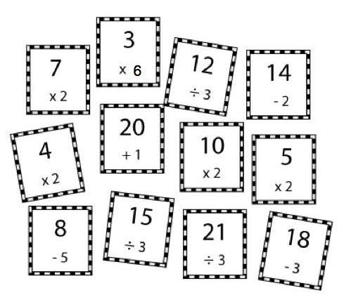
Can you sort them so that they follow round in a loop? e.g. 7X2=14 The next card would be 14-2. Does it matter which card you start with?
Here is a card from a different set.
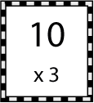
What number would follow it?
Try making your own set of cards for someone else to solve.

SCIENCE
This week I would like you to do an experiment with ice cubes. Choose three or four different places in your house to put an ice cube. First, make a prediction as to where the ice cube will melt the quickest. Place the ice cubes on a plate or in a dish and put them in your chosen places. Check on them every minute. Write up your experiment. Remember to include your prediction, what you will need, a method, your results and a conclusion.

MUSIC
If you can, listen to Saint-Saens Carnival of the Animals. Which track is your favourite and why? I can’t decide between fossils and the elephant.

ART
If you were able to listen to The Carnival of the Animals choose your favourite track to illustrate. It can be a realistic picture or an abstract one. Alternatively, create a picture of your pet. You can choose any medium you like. Paint, pencil, felt tip, playdoh, collage are a few ideas.

PE
Try to be active for at least 30 minutes a day. Go for a walk, ride your bike, make an obstacle course in the garden, do a workout.

