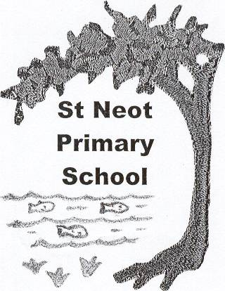
St Neot Community Primary School, Loveny Road, St Neot, Liskeard, Cornwall PL14 6NL

Tel. 01579 320580 Email- secretary@st-neot.cornwall.sch.uk
Headteacher: Sam Bowden Chair of Governors: Rebecca Boyde

“A happy learning environment for all” www.st-neot.cornwall.sch.uk

DBS APPLICATIONS

Thank you for offering to help in our school. Please complete and return the following together with your ID:

PERSONAL DETAILS,
Title, Mr Mrs, Ms, Miss, Rev, other: …………………………..
Forename: …………………………………………………………………………
Middle Names: …………………………………………………………………
Surname: ……………………………………………………………………………
Date of Birth: _ _ / _ _ / _ _
Gender: Male/Female*
NI No. _ _ _ _ _ _ _ _ _
Language Spoken: ……………………………………………………………..
Telephone Number: ………………………………………………………….
Email address: ……………………………………………………………………

Address: ……………………………………………………………………………..
………………………………………………………………………………………………..
Town: …………………………………………………………………………………….
County: ………………………………………………………………………………….
UK
Postcode: _ _ _ _ _ _ _ _
Date moved to this address: _ _ / _ _ / _ _

Please give 5 years address history (see over)
Address: ……………………………………………………………………………..
………………………………………………………………………………………………..
Town: …………………………………………………………………………………….
County: ………………………………………………………………………………….
UK
Postcode: _ _ _ _ _ _ _ _
Date moved to this address: _ _ / _ _ / _ _

Address: ……………………………………………………………………………..
………………………………………………………………………………………………..
Town: …………………………………………………………………………………….
County: ………………………………………………………………………………….
UK
Postcode: _ _ _ _ _ _ _ _
Date moved to this address: _ _ / _ _ / _ _

Town of Birth: …………………………………………………………………….
County: ………………………………………………………………………………….
Country: ………………………………………………………………………………..
Nationality at Birth: …………………………………………………………..
Have you changed your nationality since birth: Yes/No*
Surname at birth: ……………………………………………………………….
Used until: …………………………………………………………………………….
Other names: ……………………………………………………… From_ _ / _ _ / _ _ to _ _ / _ _ / _ _
Other names: ……………………………………………………… From_ _ / _ _ / _ _ to _ _ / _ _ / _ _
Other names: ……………………………………………………… From_ _ / _ _ / _ _ to _ _ / _ _ / _ _

Capacity in which you are volunteering to help? (ie reading with children, assisting on school trip, helping with after school clubs etc.) …………………………………………………………………
Do you have any unspent convictions: Yes/No*

Please complete the above and return to the school office with 3 or 4 documents proving identity, (passport, driving licence, birth certificate, marriage certificate, financial statement, etc.) Your details will be treated with the utmost confidentiality.

Once a decision has been made, we do not keep certificate information for any longer than is necessary. This is generally for a period of up to 6 months, to allow for the consideration and resolution of any disputes or complaints

If you need help completing any aspect of this form, please do not hesitate to ask.

Yours sincerely

St Neot School

